### 

### **A CRM APPLICATION FOR WHOLESALE RICE MILL**

**By**

**Madhur Singh Nain**

**madhursinghnain@gmail.com**

# **Project Abstract**

The “Wholesale Rice Mill CRM Application” is a tailored customer relationship management system designed to optimize the operations of rice mills. This application caters specifically to the needs of wholesale rice distributors, offering a comprehensive platform to manage customer relationships, streamline sales processes, and oversee inventory management. It features tools for handling customer information, tracking orders, processing billing, and maintaining real-time inventory levels, ensuring wholesalers can swiftly address market demands and customer requests. Additionally, the system includes analytical capabilities for predicting sales patterns, enhancing supply chain efficiency, and elevating customer satisfaction. By automating repetitive tasks and delivering insightful data, this CRM application is intended to increase efficiency, lower operational expenses, and strengthen customer connections.

# **INDEX Page**

------------------------------------------------------------------------------------------

Topics Page no

------------------------------------------------------------------------------------------

Introduction - - - - - - - - - - - - - - - - - - - - - - - - - - - - - - - - - - - 04

Task 1: Creating Account - - - - - - - - - - - - - - - - - - - - - - - - - 05

Task 2: Creating Objects - - - - - - - - - - - - - - - - - - - - - - - - - - 06

Task 3: Creating Tabs. - - - - - - - - - - - - - - - - - - - - - - - - - - - 10

Task 4: Creating Lightning Tabs - - - - - - - - - - - - - - - - - - - - - 12

Task 5: Creating Fields - - - - - - - - - - - - - - - - - - - - - - - - - - - 14

Task 6: Creating Page Layouts - - - - - - - - - - - - - - - - - - - - - 26

Task 7: Creating Profiles. - - - - - - - - - - - - - - - - - - - - - - - - - 28

Task 8: Creating Role & Role Hierarchy - - - - - - - - - - - - - - - 30

Task 9: Creating Users - - - - - - - - - - - - - - - - - - - - - - - - - - - 32

Task 10: Creating Permission Sets - - - - - - - - - - - - - - - - - - 34

Task 11: Creating Reports. - - - - - - - - - - - - - - - - - - - - - - - - 35

Task 12: Creating Dashboard - - - - - - - - - - - - - - - - - - - - - - 38

Task 13: Creating Apex - - - - - - - - - - - - - - - - - - - - - - - - - - 40

# **INTRODUCTION**

In the competitive landscape of wholesale rice mills, efficient customer relationship management (CRM) is pivotal for driving business growth and ensuring customer satisfaction. This Salesforce project focuses on the development of a customized CRM application tailored to the specific needs of a wholesale rice mill. The project encompasses the creation of various Salesforce components such as custom objects, tabs, Lightning apps, fields, page layouts, profiles, roles, and role hierarchies. Additionally, it includes the management of users, permission sets, and the design of insightful reports and dashboards.

The primary objective of this CRM application is to streamline the rice mill’s business processes, enabling better management of customer interactions, sales, inventory, and logistics.

Key tasks in this project include:

1.**Creating Custom Objects and Fields:** Development of custom objects to capture specific business data, including customer information, orders, inventory, and logistics. Fields will be defined to store relevant details, ensuring that the data is accurately captured and accessible.

2.**Setting Up Tabs and Lightning Apps:** Configuration of tabs and a Lightning app to provide users with an intuitive interface, facilitating easy navigation and access to critical data.

3.**Designing Page Layouts:** Customization of page layouts to ensure that users can efficiently interact with the data, tailored to the specific roles and responsibilities within the rice mill.

4.**Managing Profiles, Roles, and Role Hierarchy:** Implementation of profiles and roles to control access to data and functionality, ensuring that users have the appropriate permissions based on their roles within the organization. A role hierarchy will be established to reflect the organization’s structure, enabling secure and efficient data sharing.

5.**User and Permission Set Management:** Creation and assignment of user accounts with corresponding permission sets to ensure that each user has access to the necessary tools and information to perform their duties effectively.

6.**Generating Reports and Dashboards:** Development of customized reports and dashboards to provide real-time insights into sales, customer interactions, inventory levels, and overall business performance. These tools will empower stakeholders to make data-driven decisions and optimize business operations.

# **Task 1: Creating Account**

1. Setting Up a Salesforce Developer Org :

* Go to <https://developer.salesforce.com/signup>
* Note : Username need not be an actual email id, you can give anything in the format : [username@organization.com](mailto:username@organization.com)

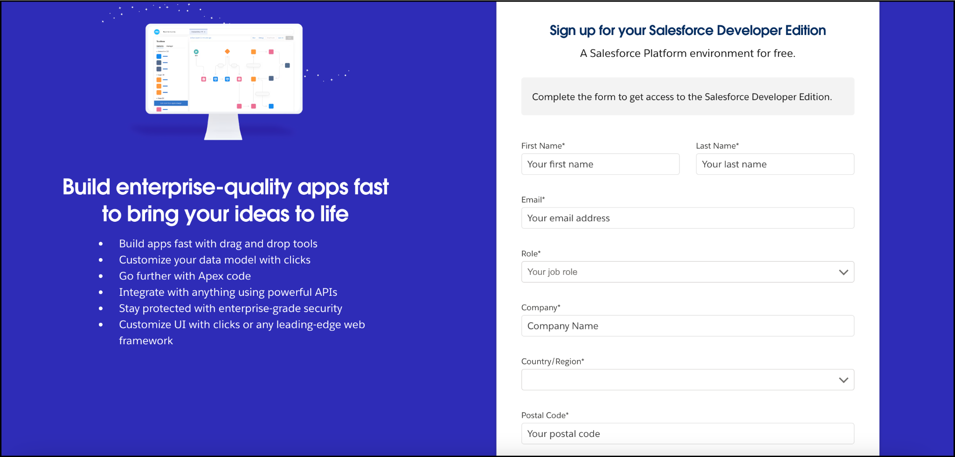

2. Activate your Salesforce Developer Account :

* Go to the inbox of the email that you used while signing up. Click on the verify account to activate your account. The email may take 5-10mins.

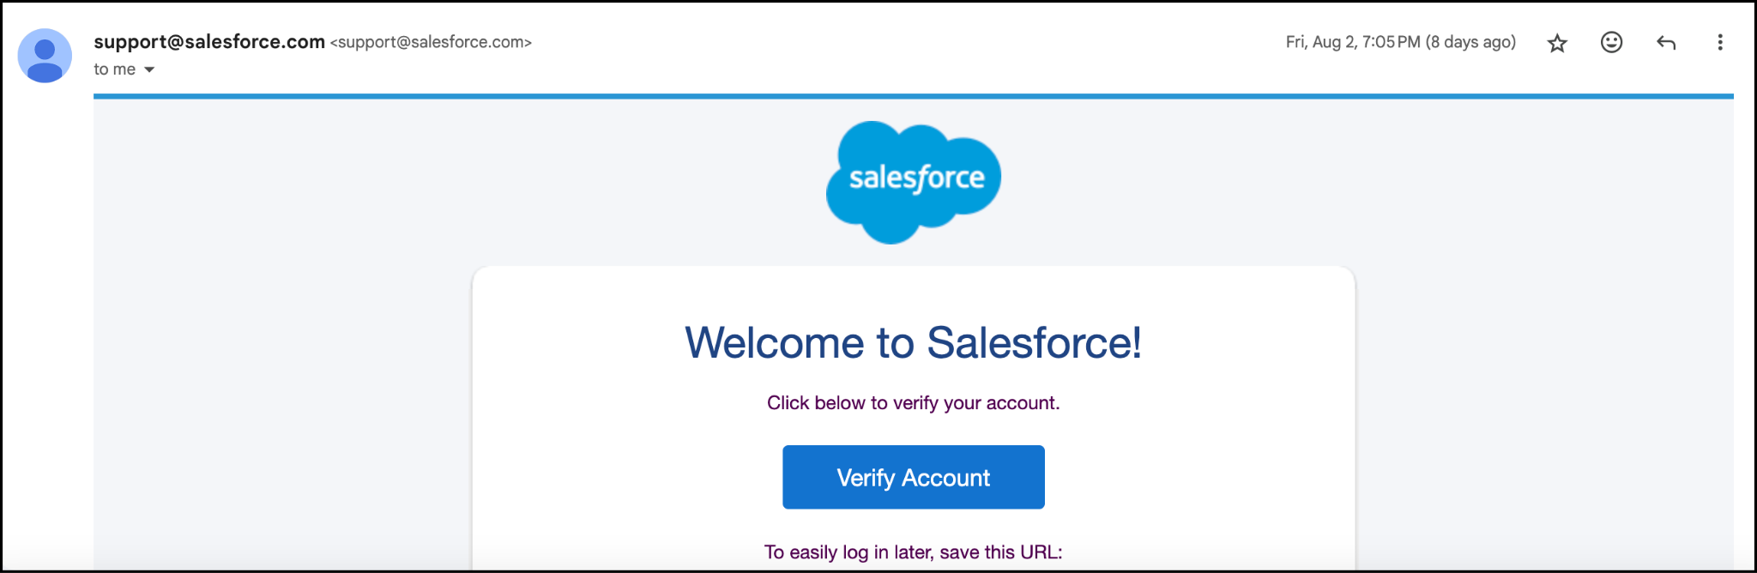

# **Task 2: Creating Objects**

1. **Create Supplier Object :**
   1. From the setup page >> Click on Object Manager>> Click on Create>>Click on Custom Object.
      1. Enter the label name>>supplier
      2. Plural label name>>supplier
   2. Enter Record Name Label and Format
   3. Record Name >> supplier Name
   4. Data Type>>Text
   5. Click on Allow reports and Track Field History and allow search
   6. Allow search >> Save.

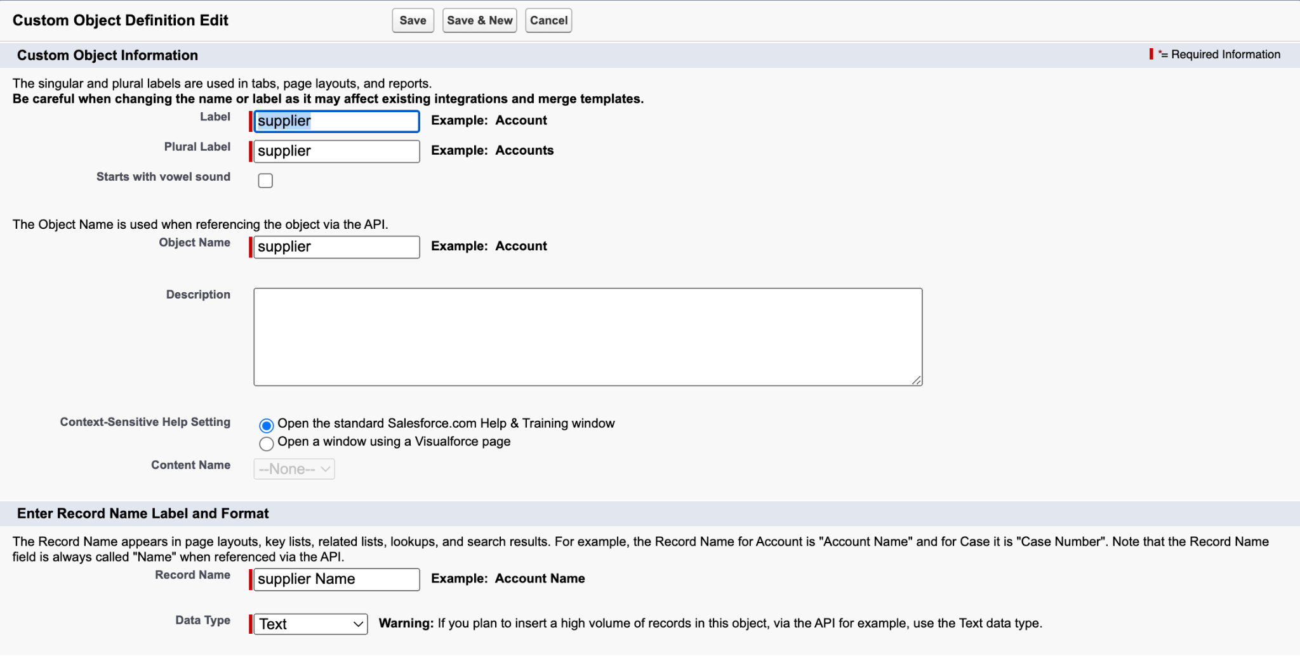

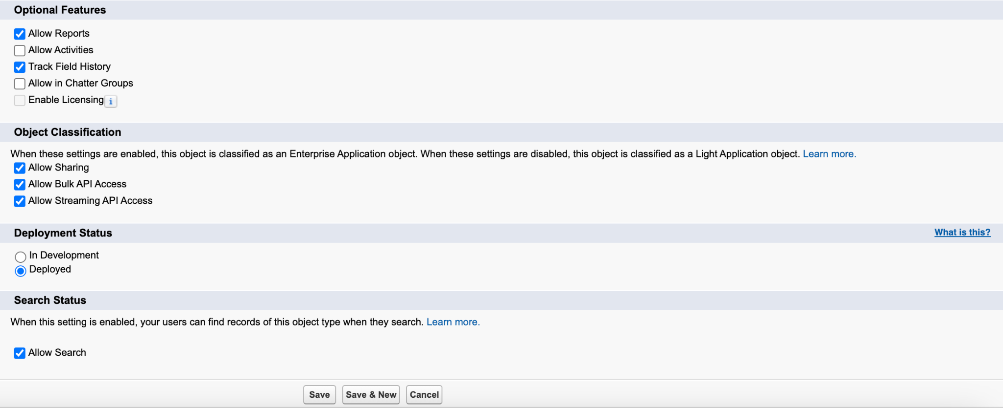

1. **Create Rice Mill Object**
   1. From the setup page >> Click on Object Manager>>Click on Create >> Click on Custom Object.
      1. Enter the label name>>rice mill
      2. Plural label name>> rice mills
      3. Enter Record Name Label and Format
      4. Record Name >>
      5. Data Type >> Auto Number
      6. Display Format >> rice-{000}
      7. Starting number >> 1
   2. Click on Allow reports and Track Field History, Allow Search and Save.

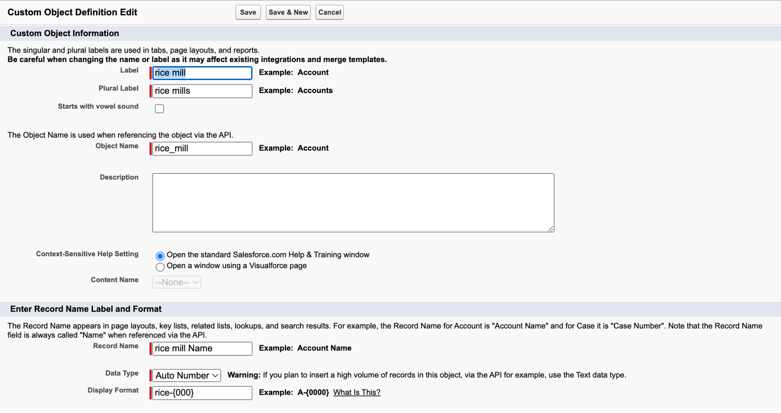

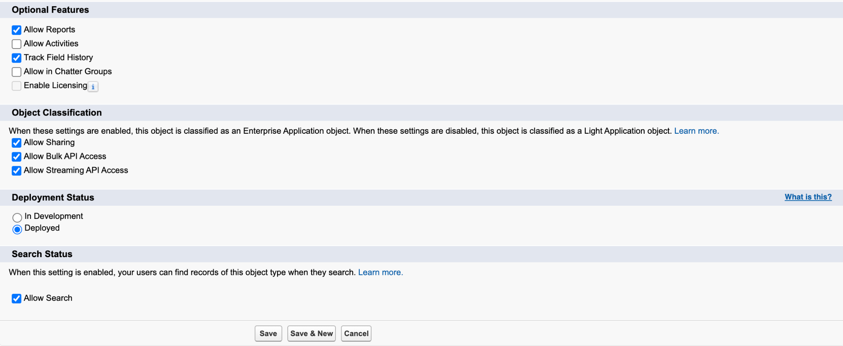

1. **Create Consumer Object** 
   1. Use these display format for the consumer
      1. label name >> consumer
      2. Plural label name >> consumers
      3. Display Format >> consumers-{000}
      4. Starting number >> 1

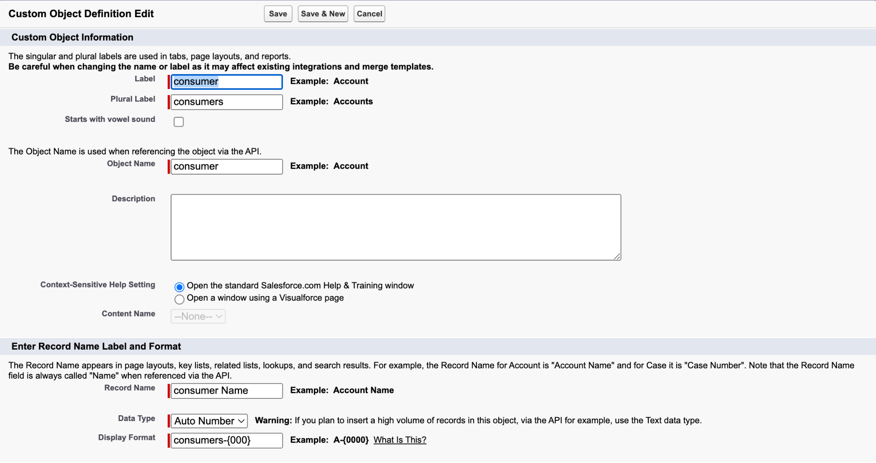



1. **Create Rice Details Object :** 
   1. Use these display format for the rice details
      1. label name >> rice details
      2. Plural label name >> rice details
      3. Display Format >> rice-{000}
      4. Starting Number >>1

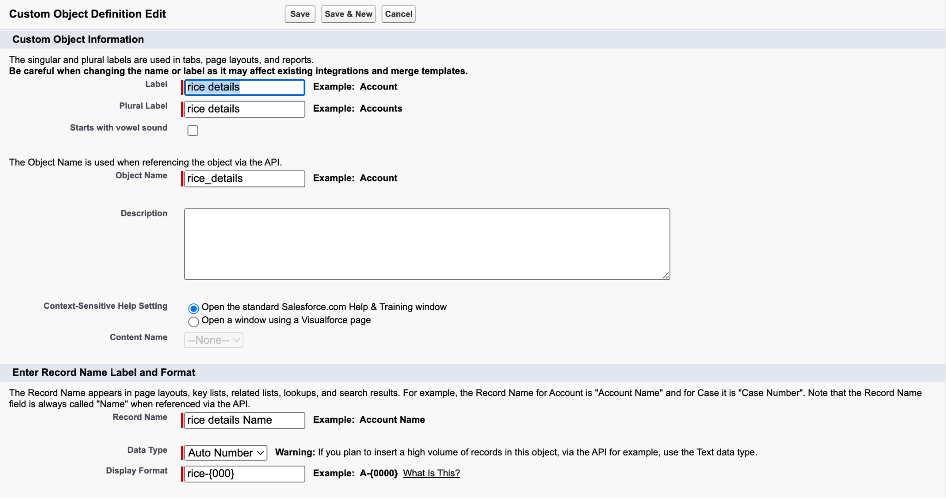

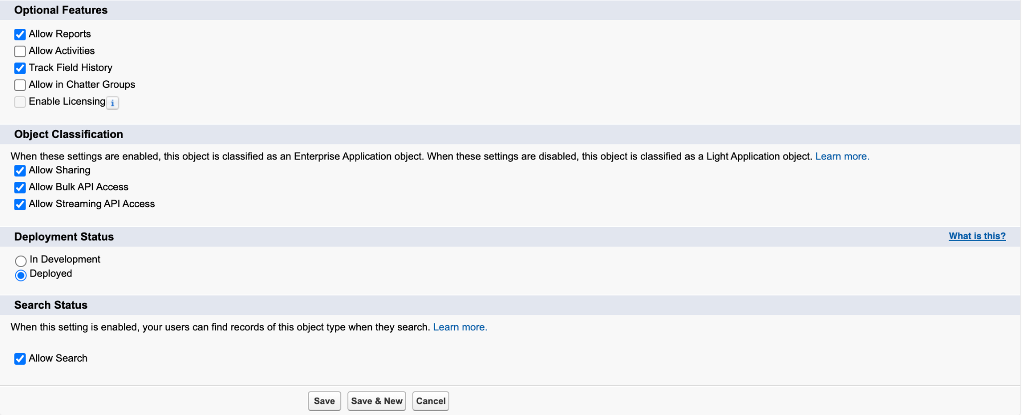

# **Task 3: Creating Tabs**

1. **Create Custom tab for Supplier Object :**
   1. Go to setup page >> type Tabs in Quick Find bar >> click on tabs >> New (under custom object tab)
   2. Select Object( supplier ) >> Select the tab style >> Next (Add to profiles page) keep it as default >> Next (Add to Custom App) uncheck the include tab .
   3. Make sure that the Append tab to users' existing personal customizations is checked.
   4. Click save.

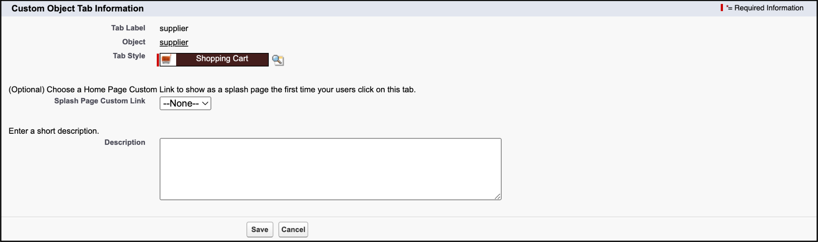

1. **Create Custom tab for Rice Mill Object :**
   1. Go to setup page >> type Tabs in Quick Find bar >> click on tabs >> New (under custom object tab)
   2. Select Object( rice mill ) >> Select the tab style >> Next (Add to profiles page) keep it as default >> Next (Add to Custom App) uncheck the include tab .
   3. Make sure that the Append tab to users' existing personal customizations is checked.
   4. Click save.

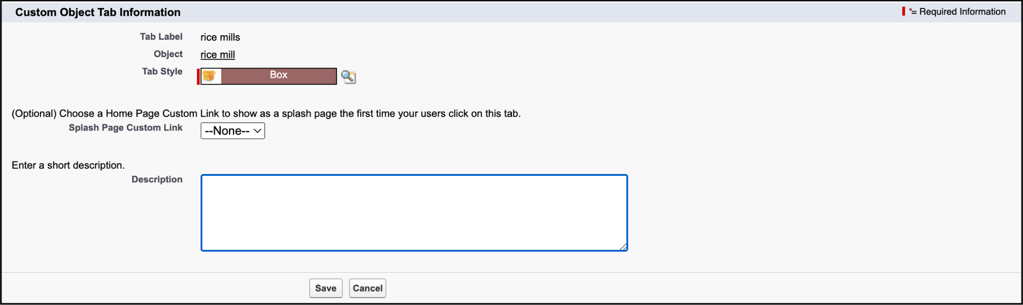

1. **Create Custom tab for Rice Details Object :**
   1. Go to setup page >> type Tabs in Quick Find bar >> click on tabs >> New (under custom object tab)
   2. Select Object( rice details ) >> Select the tab style >> Next (Add to profiles page) keep it as default >> Next (Add to Custom App) uncheck the include tab .
   3. Make sure that the Append tab to users' existing personal customizations is checked.
   4. Click save.

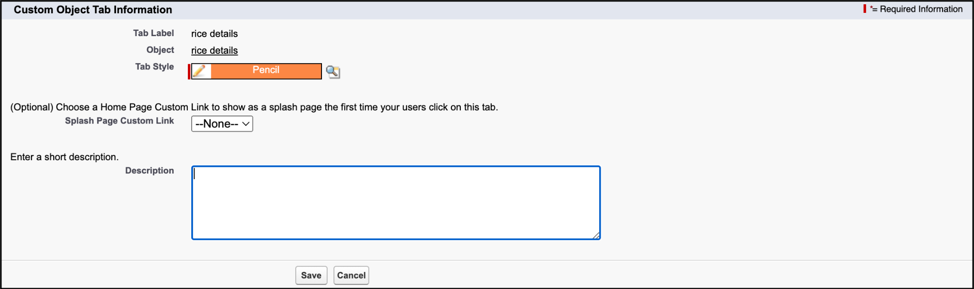

1. **Create Custom tab for Consumer Object :**
   1. Go to setup page >> type Tabs in Quick Find bar >> click on tabs >> New (under custom object tab)
   2. Select Object( consumer ) >> Select the tab style >> Next (Add to profiles page) keep it as default >> Next (Add to Custom App) uncheck the include tab .
   3. Make sure that the Append tab to users' existing personal customizations is checked.
   4. Click save.

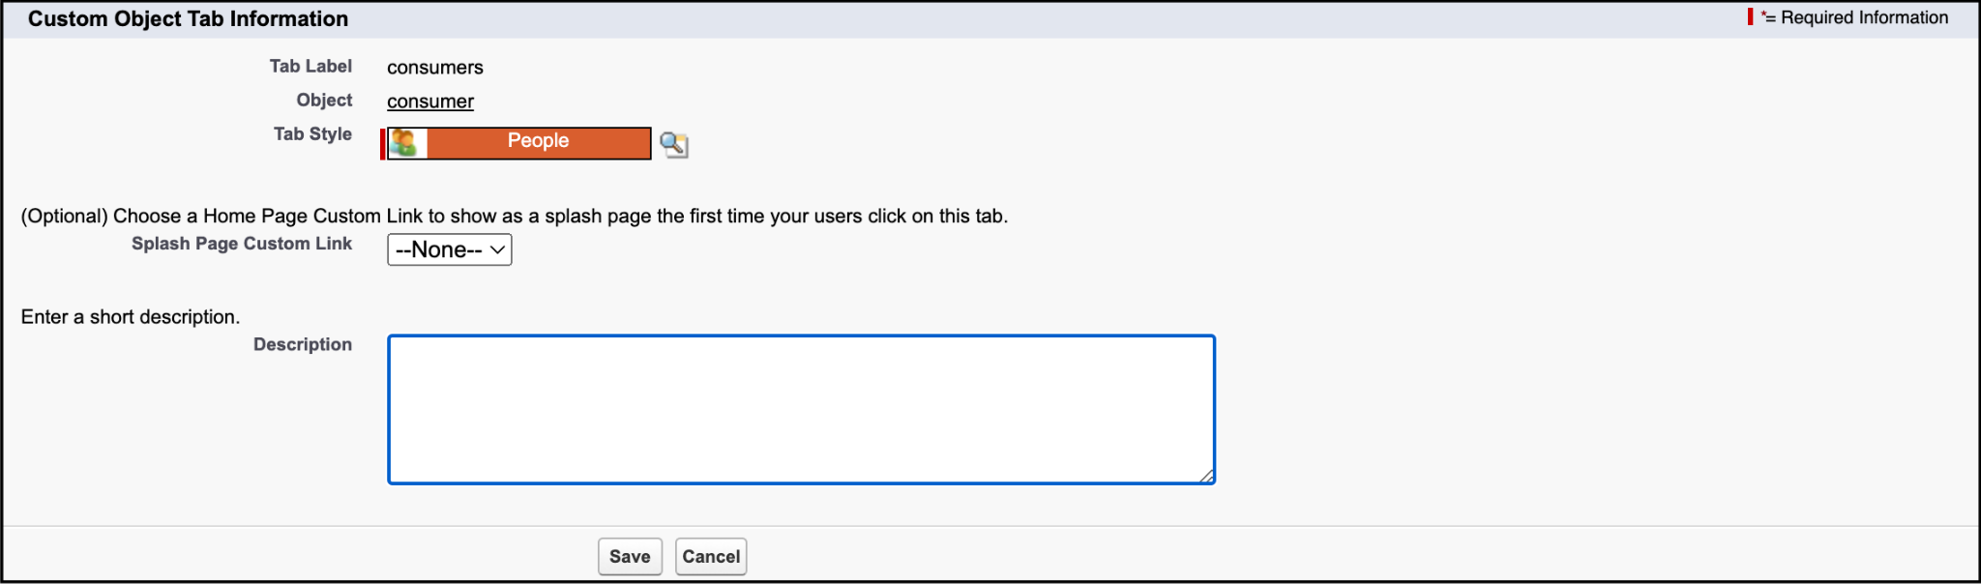

# **Task 4: Creating Lightning Tabs**

**To create a lightning app page:**

1. Go to setup page >> search “app manager” in quick find >> select “app manager” >> click on New lightning App.

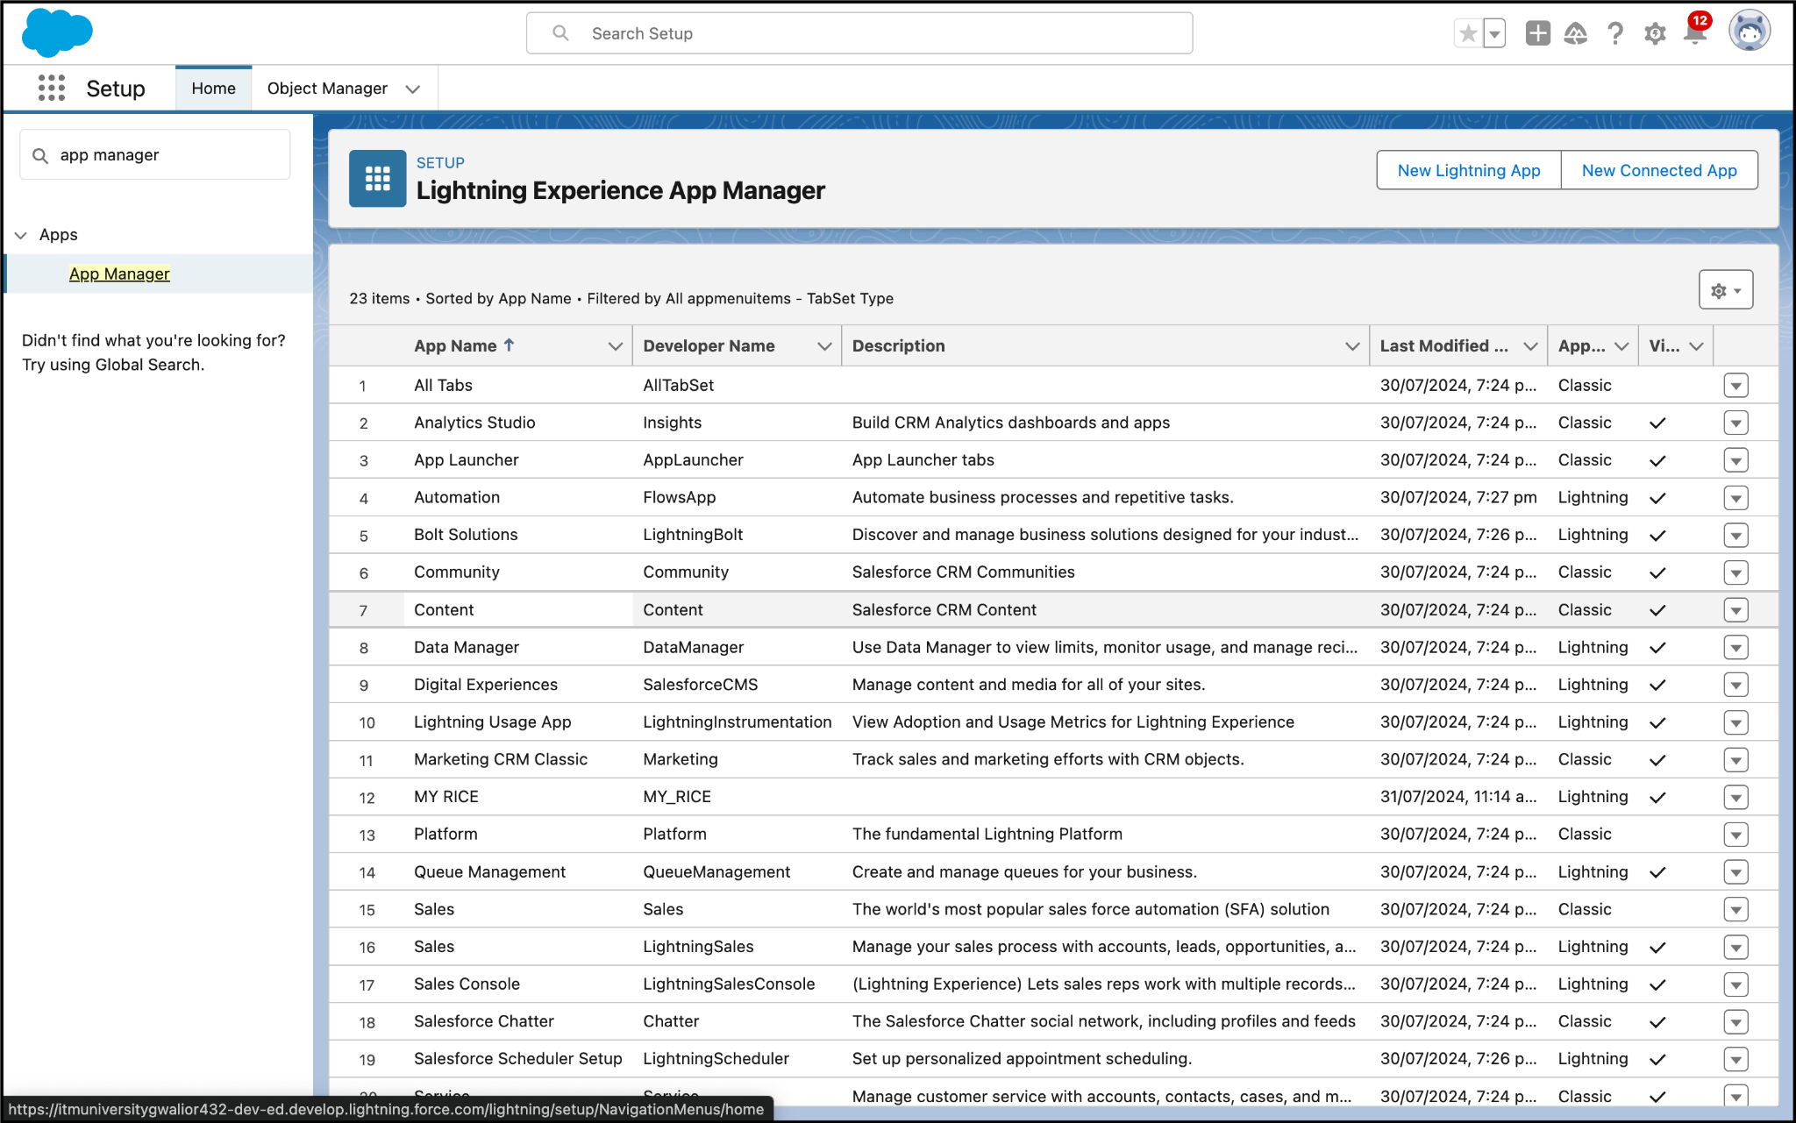

1. Fill the app name in app details as MY RICE >> Next >> (App option page) keep it as default >> Next >> (Utility Items) keep it as default >> Next.

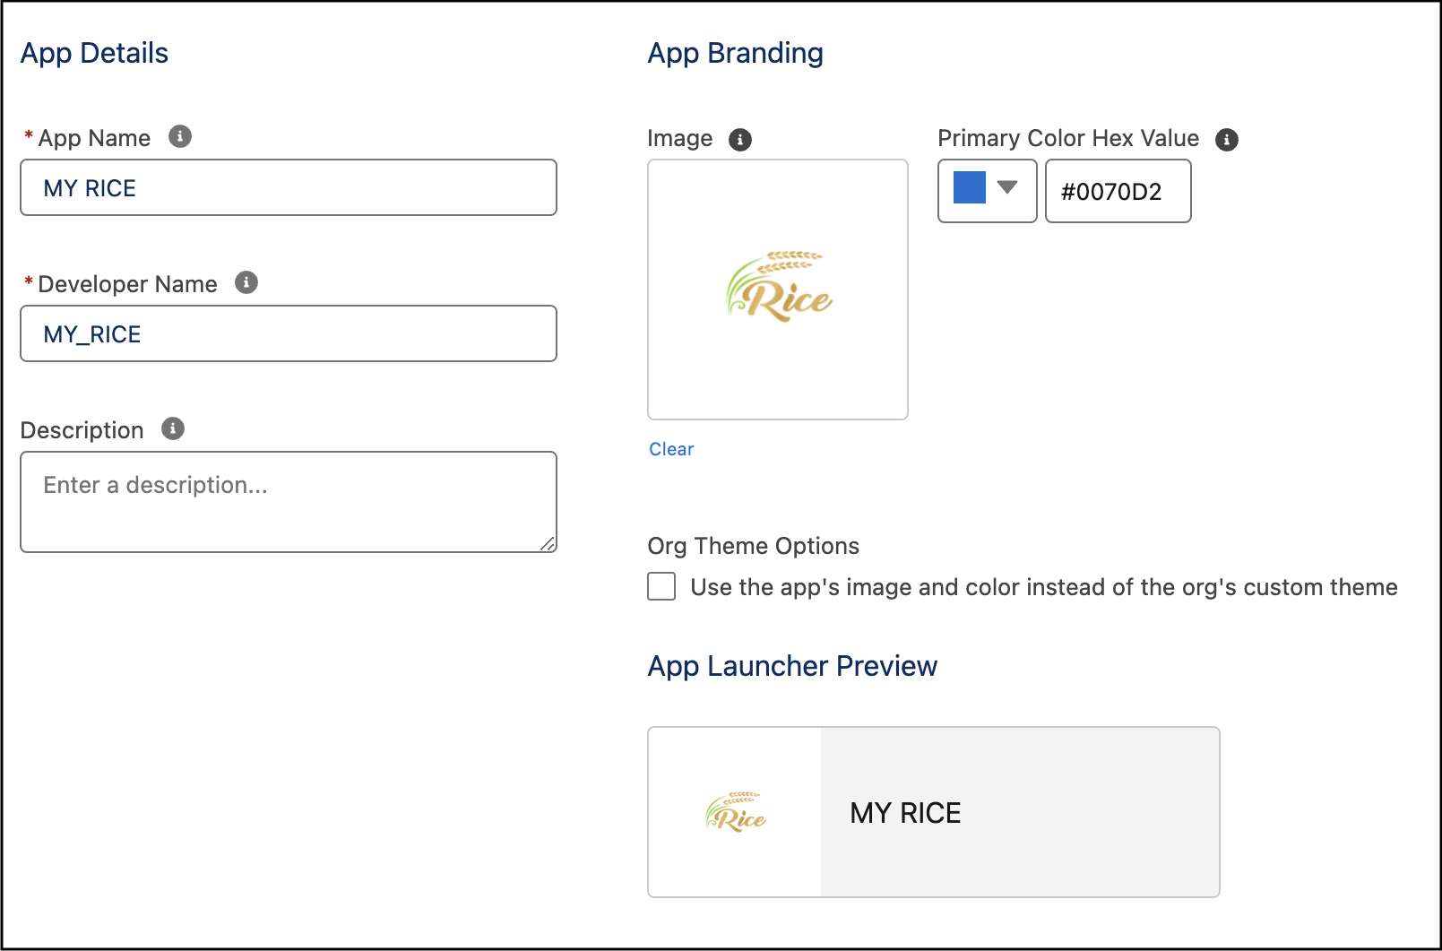

1. Upload a photo that is related to your app.
2. To add Navigation Item:

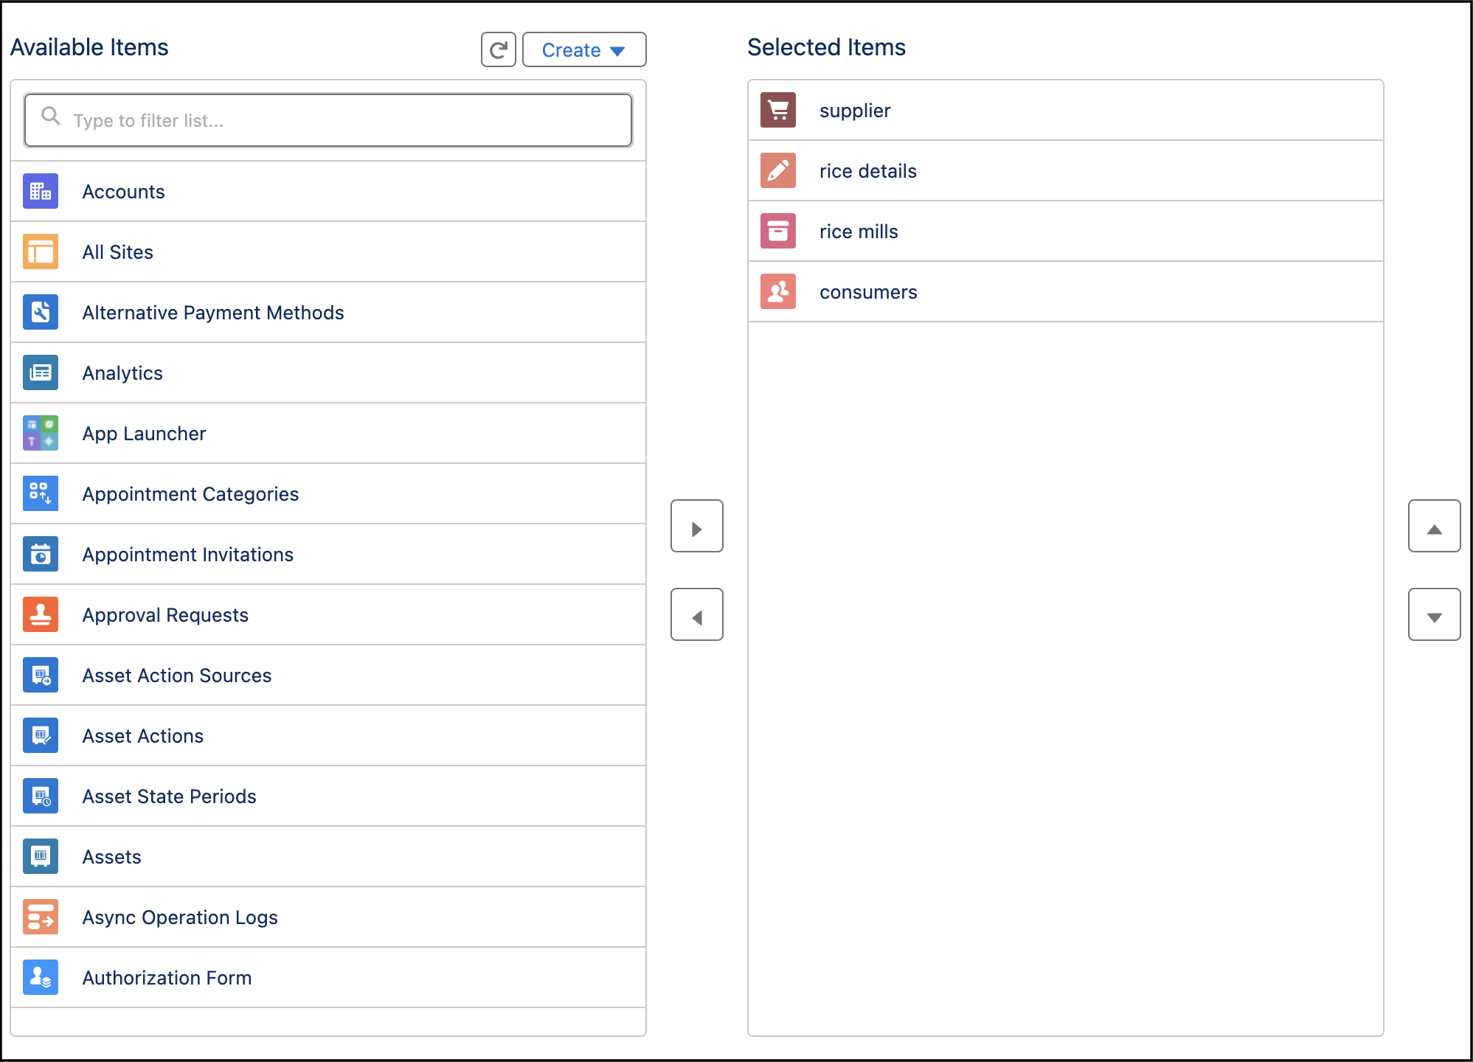

1. Select the items (supplier, rice mill, consumer, rice details).
2. To Add User Profiles:

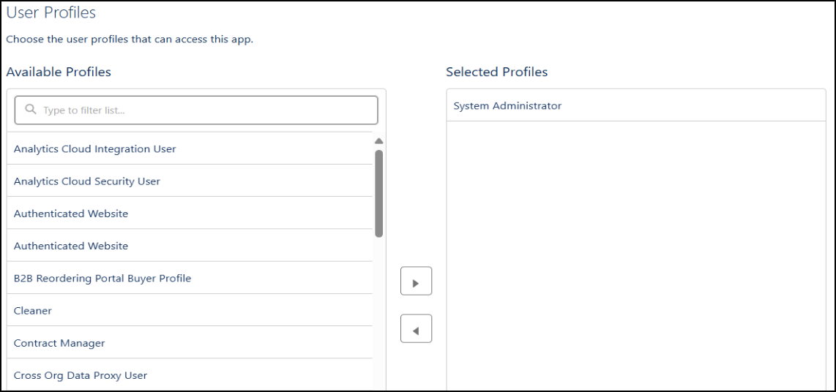

Search profiles (System administrator) in the search bar >> click on the arrow button >> save & finish.

# **Task 5: Creating Fields**

**Creating the number field in rice details object**

1. Go to the setup page >> click on object manager >> From drop down click edit for rice details object.
2. Click on fields & relationship >> click on New.

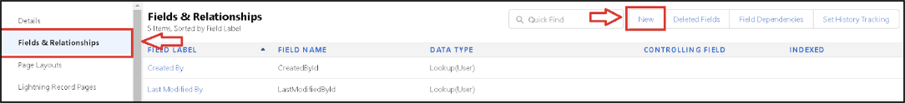

1. Select Data type as “Number” and click Next.
2. Given the Field Label as “ rice distributed ” and length as “ 5 ”.
3. Field Name will be auto populated, and click on Next- Next >> Save.

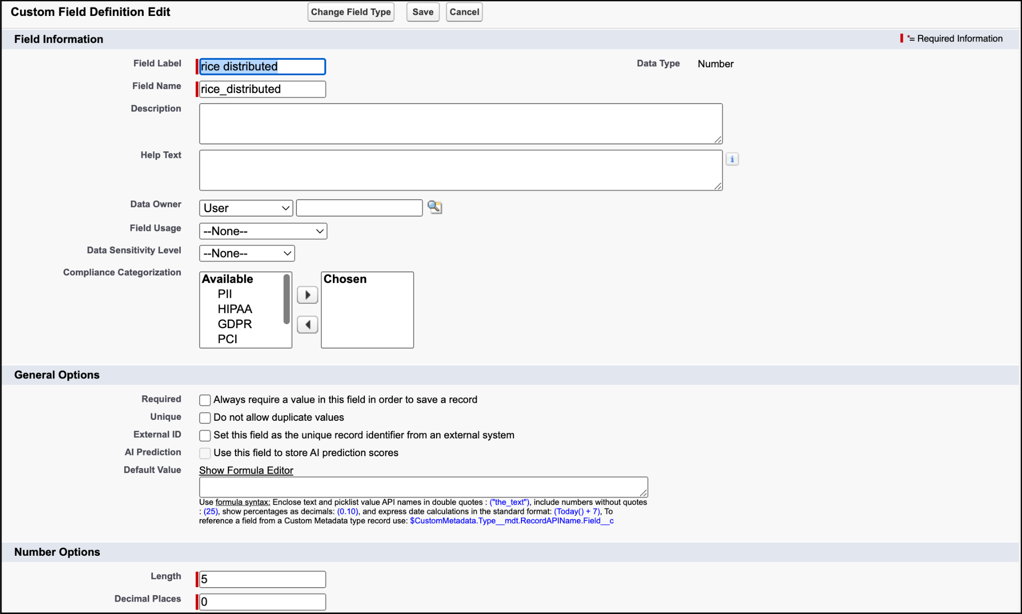

**Creating junction object as rice details with supplier & rice mill**

1. Go to the setup page >> click on object manager >> From drop down click edit for rice details object.
2. Click on fields & relationship - click on New.
3. Select “Master-Detail relationship” as data type and click Next.
4. Select the related object “ supplier ” and click next.
5. Give Field Label as “supplier Name” and click Next.
6. Next >> Next >> Save & New.

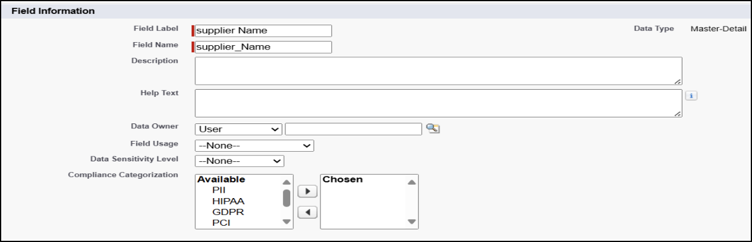

1. Follow the same steps from 1 to 3.
2. Select the related object “ rice mill ” and click Next.
3. Give Field Label as “rice mill 1(one)” and click Next.
4. Next >> Next >> Save.

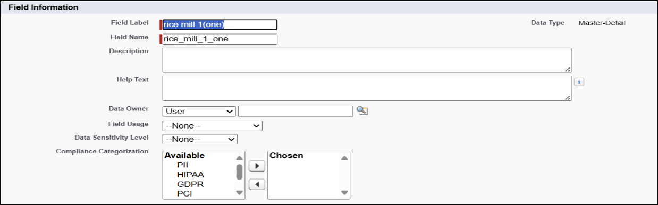

**Creating Master-Detail Relationship between consumer & rice mill Object**

1. Go to the setup page >> click on object manager >> From drop down click edit for consumer object.
2. Click on fields & relationship >> click on New.
3. Select “Master-Detail relationship” as data type and click Next.
4. Select the related object “ rice mill”.
5. Give Field Label as “rice mill name” and click Next.
6. Next >> Next >> Save.

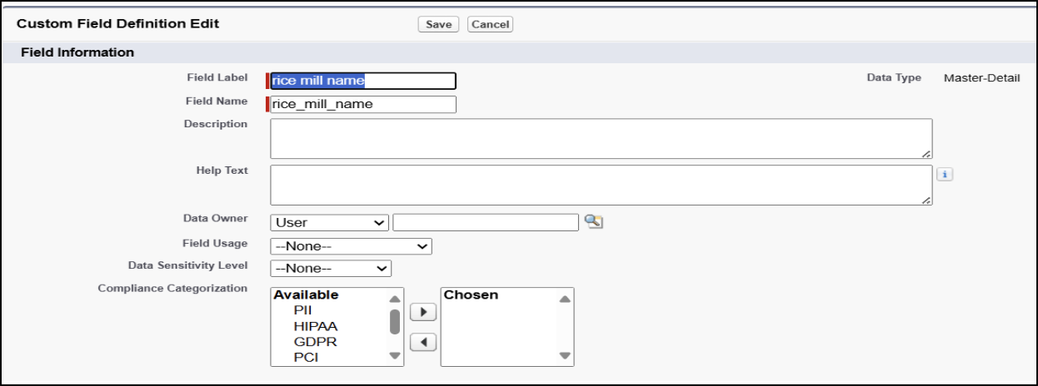

**Creating the Roll-up summary field on supplier & rice mill Objects**

1. Go to setup >> click on Object Manager >> type object name(supplier) in search bar >> click on the object.
2. Now click on “Fields & Relationships” >> New
3. Select the data type as “Rollup summary ”,and click Next.
4. Give the Field label as “ sum of rice distributed ”,Field Name will be Auto generated, and click Next.

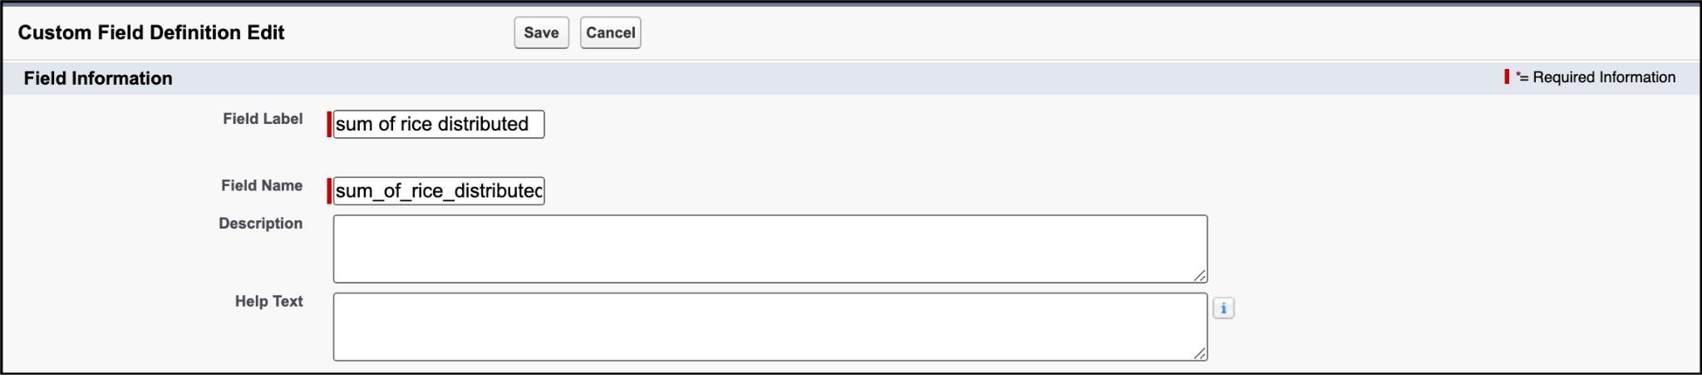

1. Select the summarized object as “ rice details ”.
2. Select the Rollup type as “sum”.
3. Select the field to aggregate as “ rice distributed ”, and click Next >>Next >>Save.

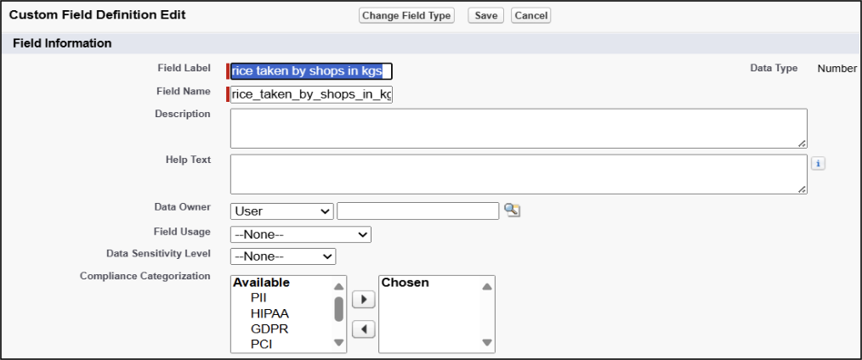

1. Follow the same steps for the rice mill Object from 1 to 3
2. Give the Field label as “ rice distributed to shops ”,Field Name will be Auto generated, and click Next.

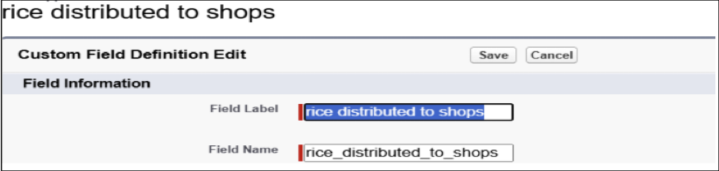

1. Select the summarized object as “ rice details ”.
2. Select the Rollup type as “sum”.

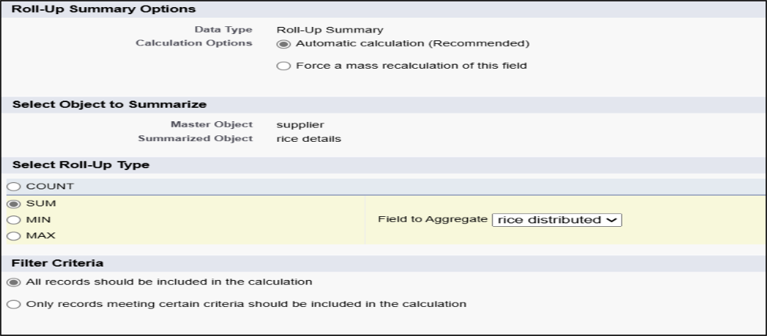

1. Select the field to aggregate as “ rice distributed ”, and click Next >> Next >> Save.
2. Create the field as “ rice taken by shops in kgs” using number datatype in consumer object.



1. Follow the same steps for the rice mill Object from 1 to 3
2. Give the Field label as “ rice taken ”,Field Name will be Auto generated, and click Next.

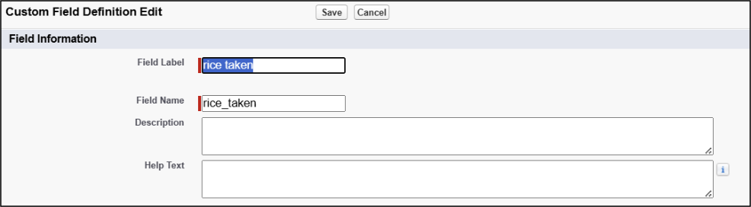

1. Select the summarized object as “ consumer”.
2. Select the Rollup type as “sum”.
3. Select the field to aggregate as “ rice taken in shops ”, and click Next >> Next >> Save.

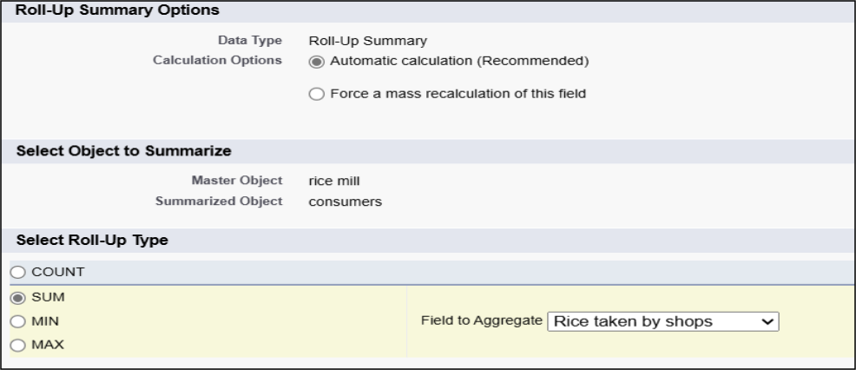

**Creating the number field in rice details object**

1. Go to the setup page >> click on object manager >> From drop down click edit for rice details object.
2. Click on fields & relationship >> click on New.
3. Select Data type as “master detail” and click Next.
4. Given the Field Label as “ supplier name ” and length as “ 5
5. Field Name will be auto populated, and click on Next>> Next >>Save.

**Creating Fields in rice mill object**

1. Select Data type as “Number” and click Next.
2. Given the Field Label as “ rice price/kg ” and length as “ 5 ”

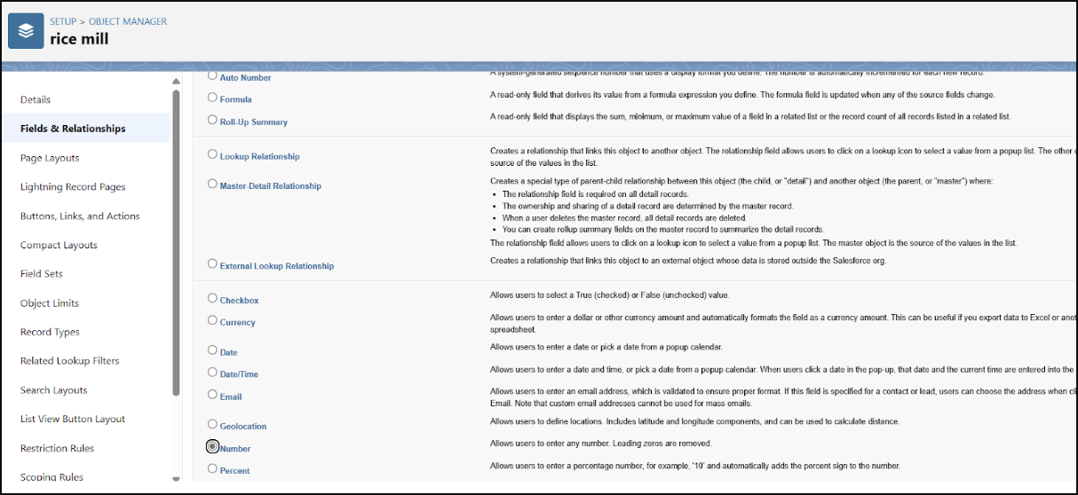

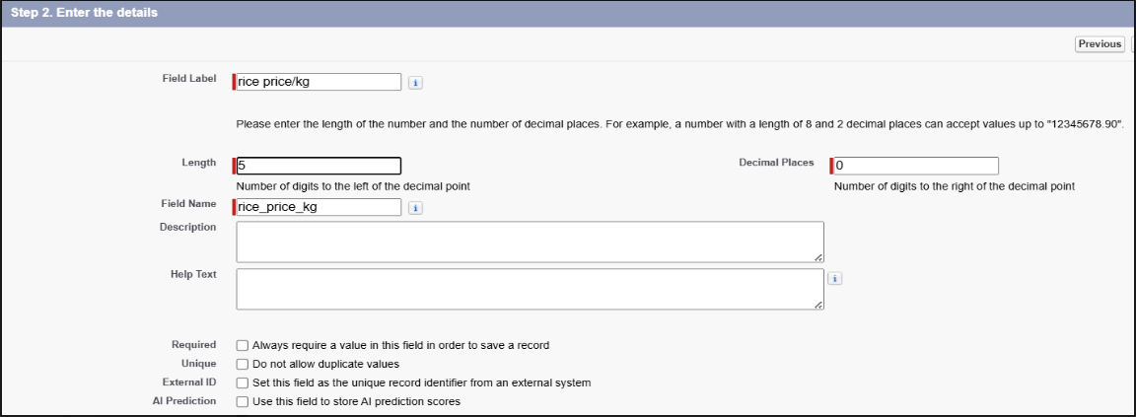

**Creating Fields in consumer object**

1. Create a “First name” field, Data Type - “text”.

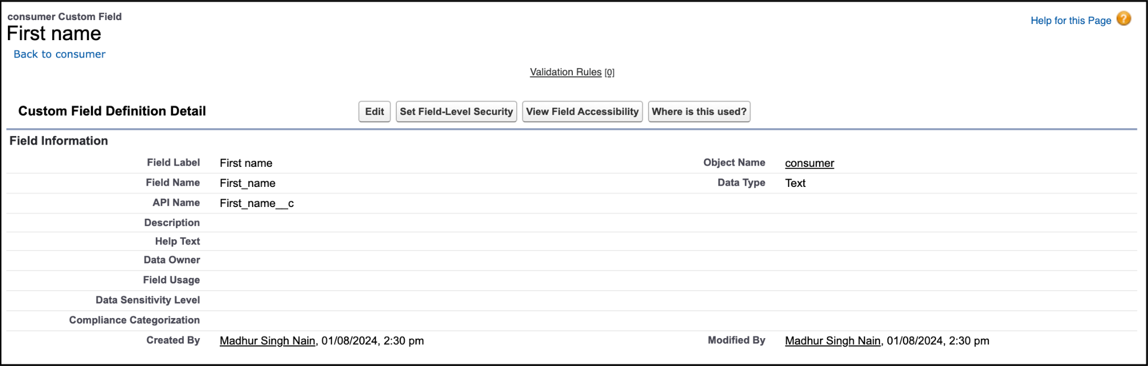

1. Create a “Last name” field, Data Type - “text”.

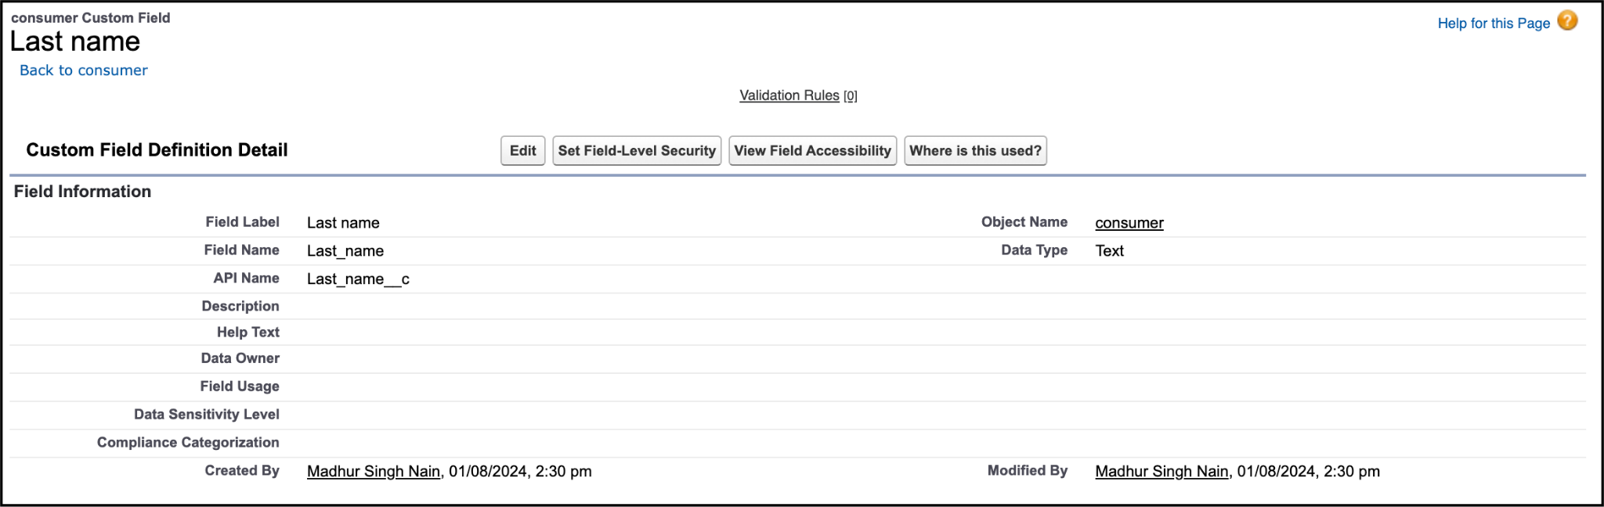

1. Create a “Phone number” field, Data Type - “Phone”.

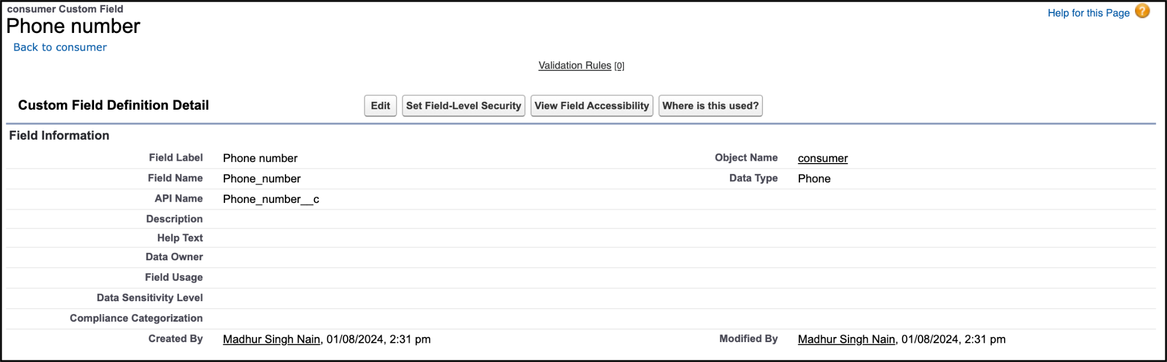

1. Create a “email” field, Data Type - “Email”.

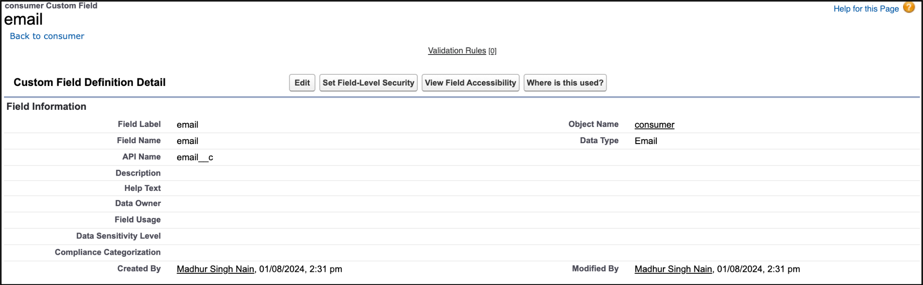

1. Create a “Rice taken by shops” field, Data Type - “Number”,length=5.

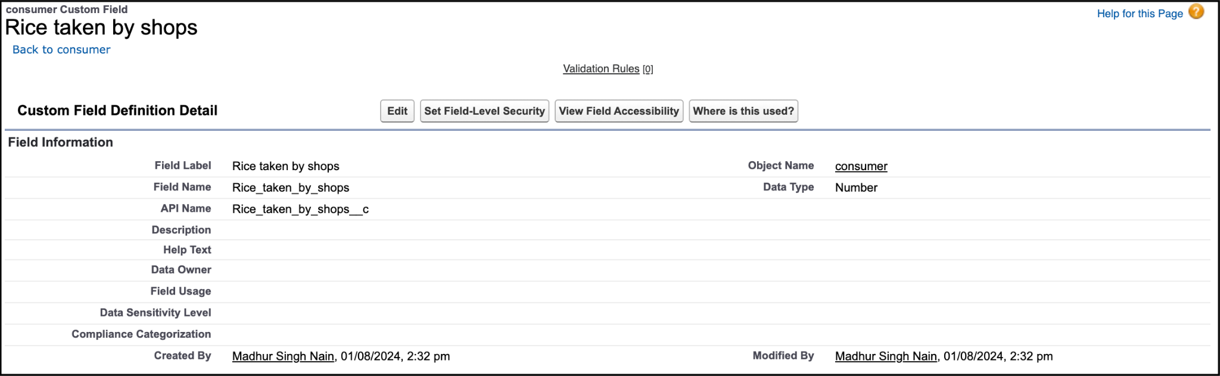

1. Create a “Rice type” field, Data Type - “Picklist”.
   1. Picklist values :
   2. Basmati
   3. Normal rice

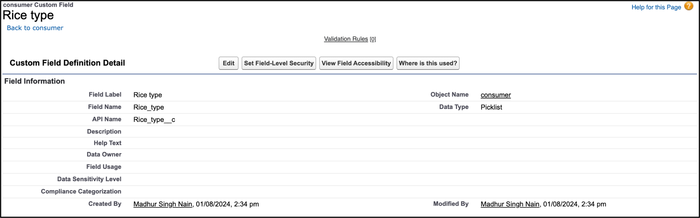

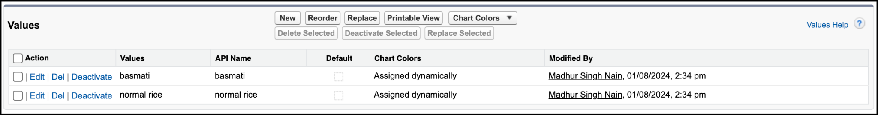

1. Create a “Mode of payment” field, Data Type - “Picklist”.
   1. Picklist values :
      1. Credit card
      2. Debit card
      3. Net banking
      4. UPI
      5. Cash

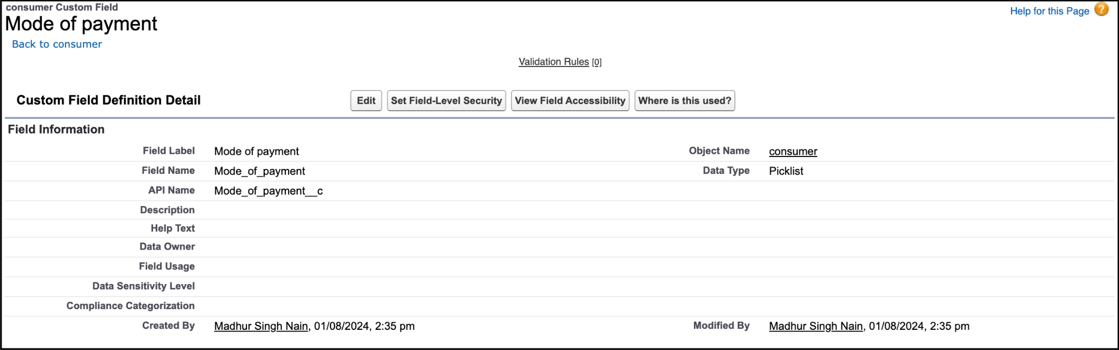

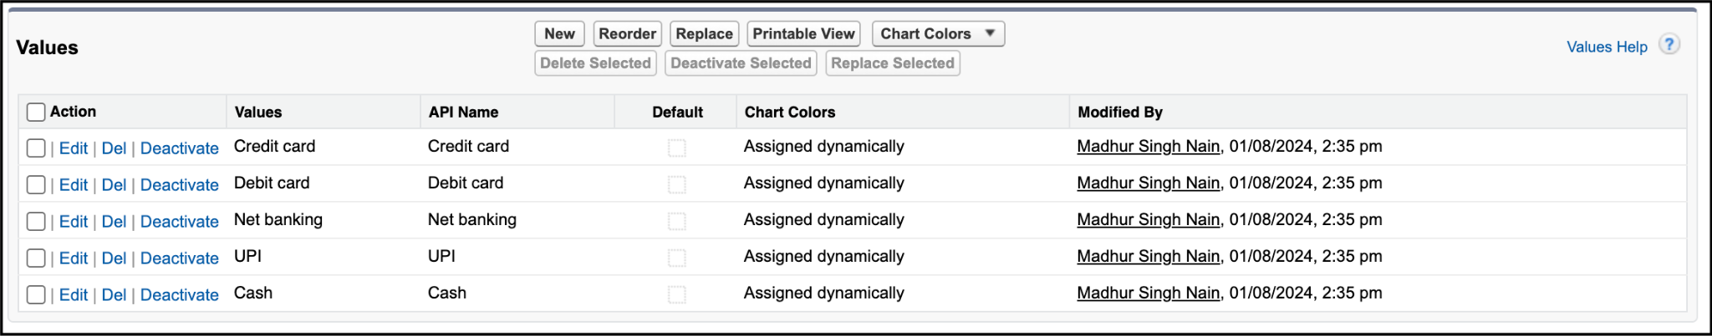

**Creating Cross Object Formula Field In Consumer Object**

1. Go to setup >> click on Object Manager >> type object name(consumer) in search bar >> click on the object.
2. Click on fields & relationship >> click on New.
3. Select Data type as “Formula” and click Next.
4. Give Field Label and Field Name as “Amount Paid ” and select formula return type as “Number” and click next.

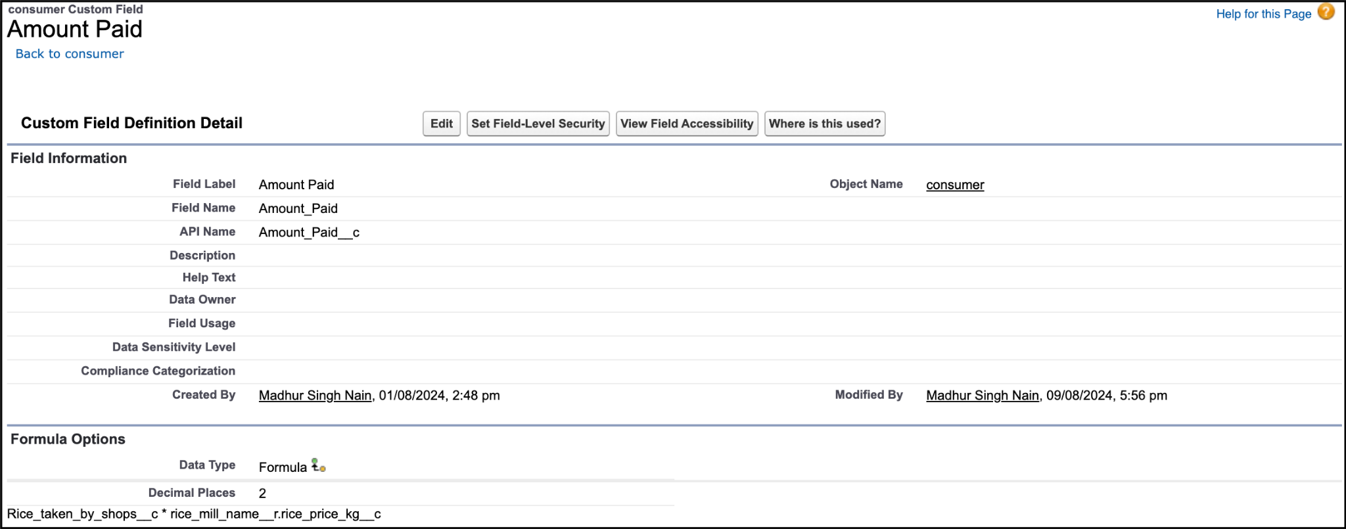

1. Insert fields formula should be :  
   rice_taken_by_shops__c * rice_mill_name__r.rice_price_kg__c
2. Under Advanced Formula write down the formula and click “Check Syntax” and Save.

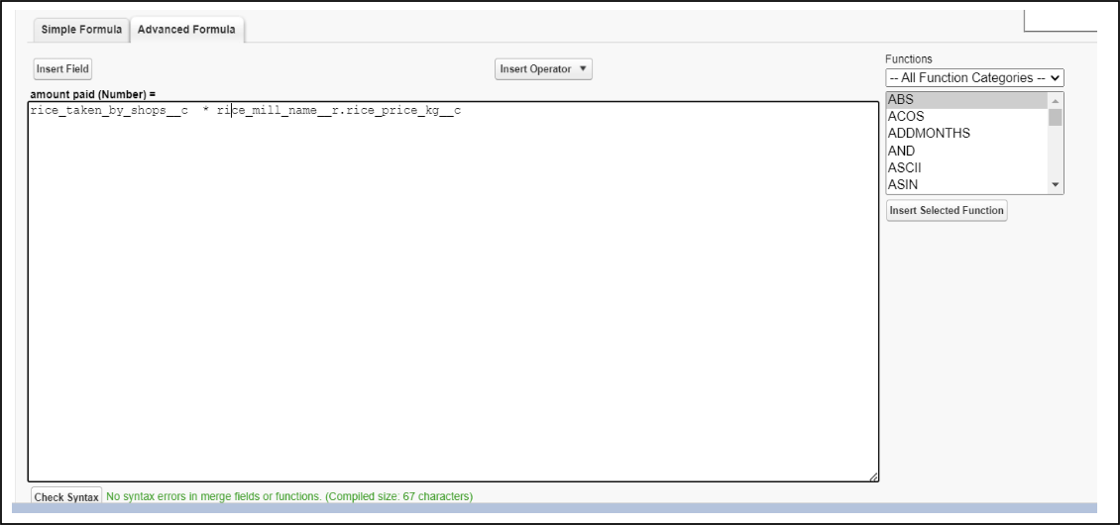

**Creating the Formula field in consumer Object**

1. Go to setup >> click on Object Manager >> type object name(consumer) in search bar >> click on the object.
2. Click on fields & relationship >> click on New.
3. Select Data type as “Formula” and click Next.
4. Give Field Label and Field Name as “Consumer Name” and select formula return type as “TEXT” and click next.
5. Insert field formula should be : First_Name__c + ' ' + Last_Name__c
6. click “Check Syntax” and Save.

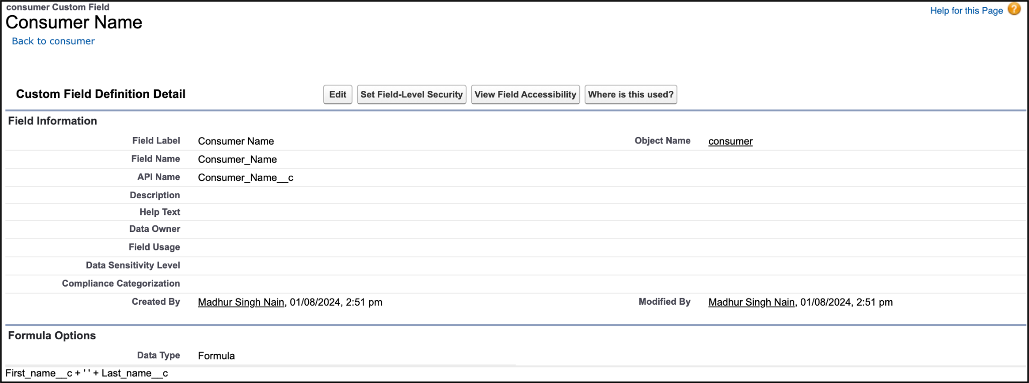

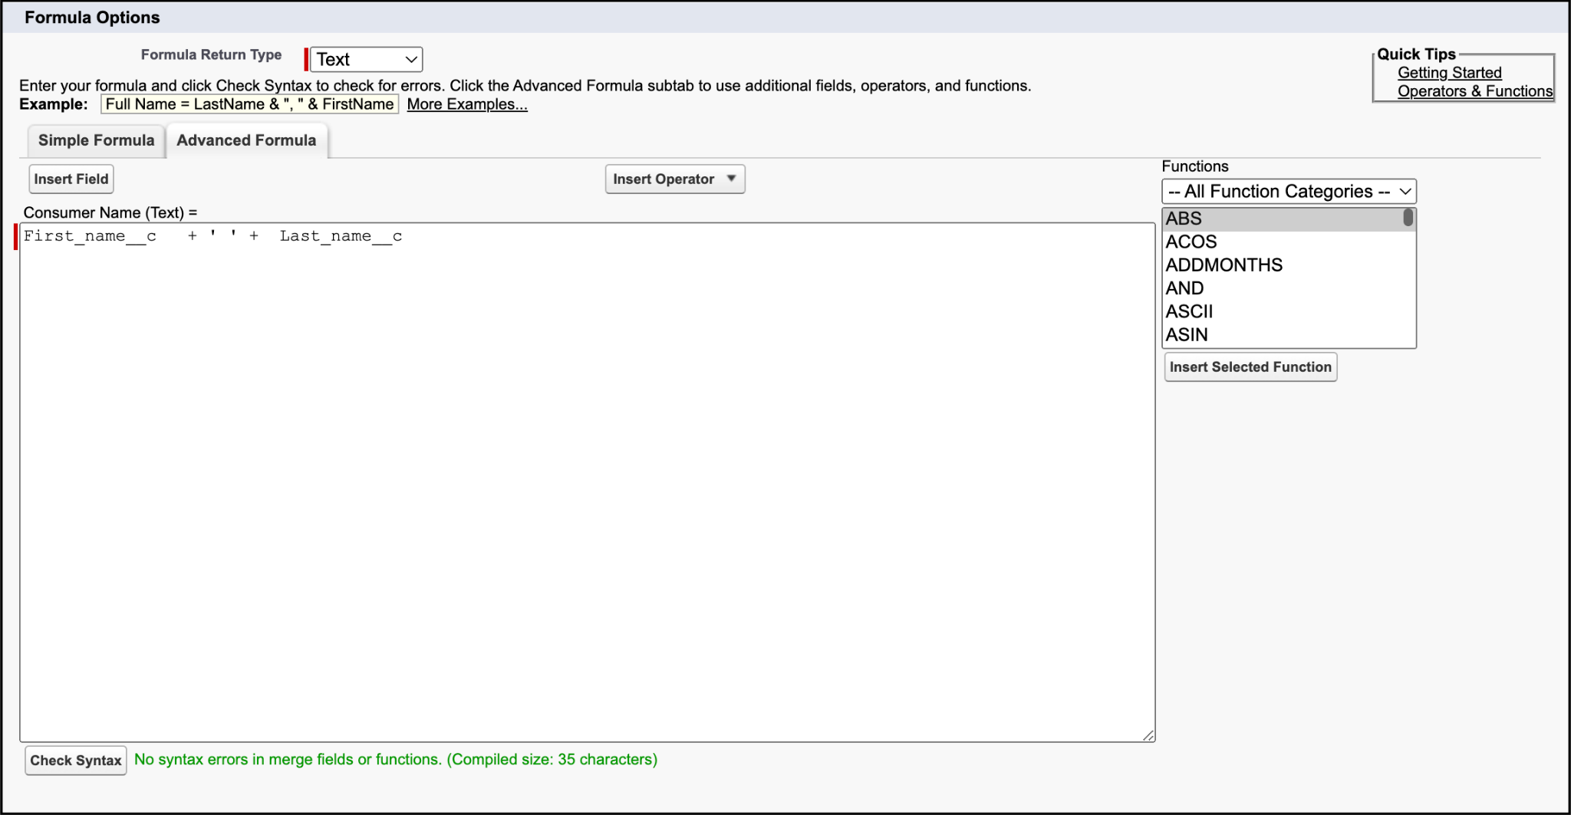

**Creating The Validation Rule**

1. Go to the setup page >>click on object manager >> From drop down click edit for consumer object.
2. Click on the validation rule >> click New.

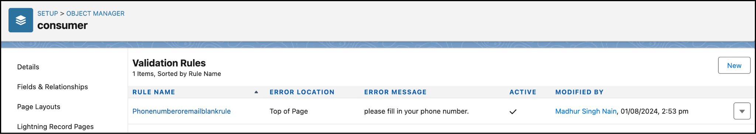

1. Enter the Rule name as “Phonenumberoremailblankrule ”.
2. Enter the description as “phone number and email number should not be blank”.
3. Enter the formula as “OR( ISBLANK( phone_number__c ) , ISBLANK( email__c ) )” and check the syntax.

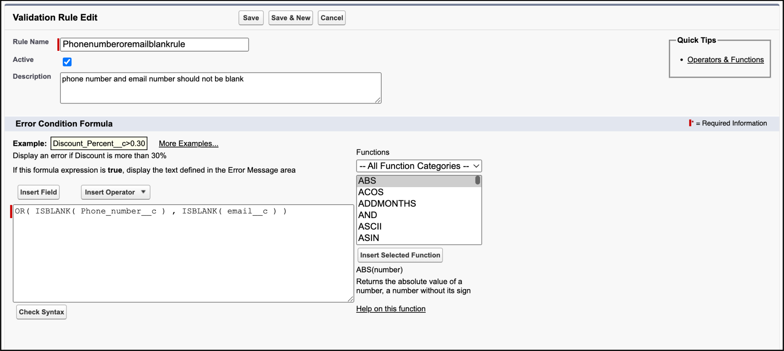

1. Under the error message write as”please fill in your phone number.”
2. Select error location “top of page”.

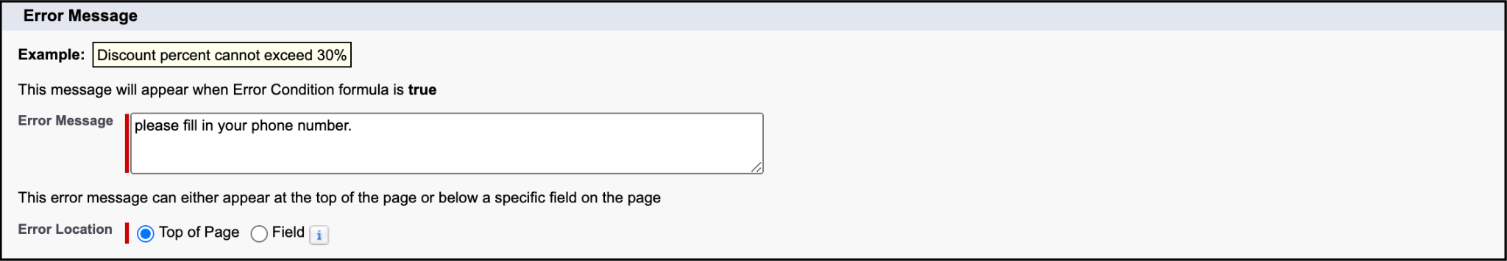

1. Save the validation rule.

# **Task 6: Creating Page Layouts**

**To Create a Page Layout**

1. Go to Setup >> Click on Object Manager >>Search for the object (consumer) >> From drop down select the object and click on it.
2. Click on Page layout >> Click on New.

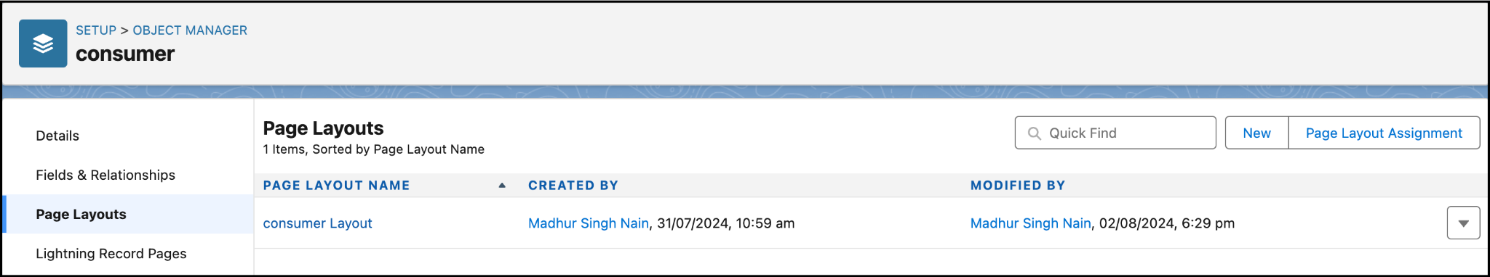

1. Select the existing page layout, and give the page layout name as “consumer layout”, and click save.
2. Drag and drop the section field to consumer details and create the section.
3. Enter the section name as “Personal details”, - click Ok.

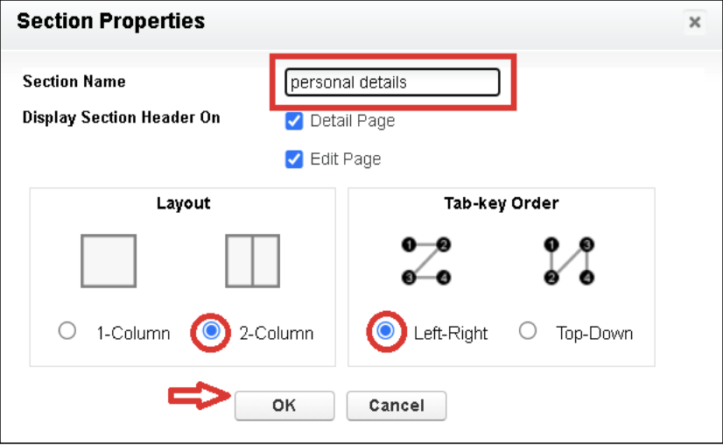

1. Now drag the fields to this section that mentioned , they are
   * First name , last name , consumer name , phone number, email, rice mill name.
2. Follow the same process for another two sections as shown above , they are
3. One section is “ rice details ” , drag the fields that are
   * Rice taken by shop, rice type.
4. Another section is “Receipt details ”, and drag the fields that are
   * Mode of payment , Amount paid.

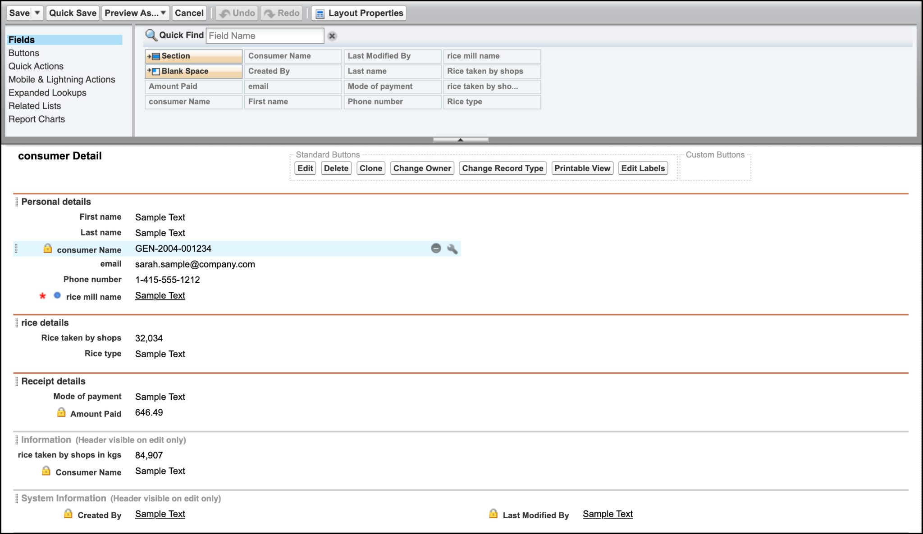

Then , Click save.

# **Task 7: Creating Profiles**

**Creating Owner Profile**

1. Go to setup >> type profiles in quick find box >> click on profiles >> clone the desired profile (Standard User) >>enter profile name (owner) >> Save.

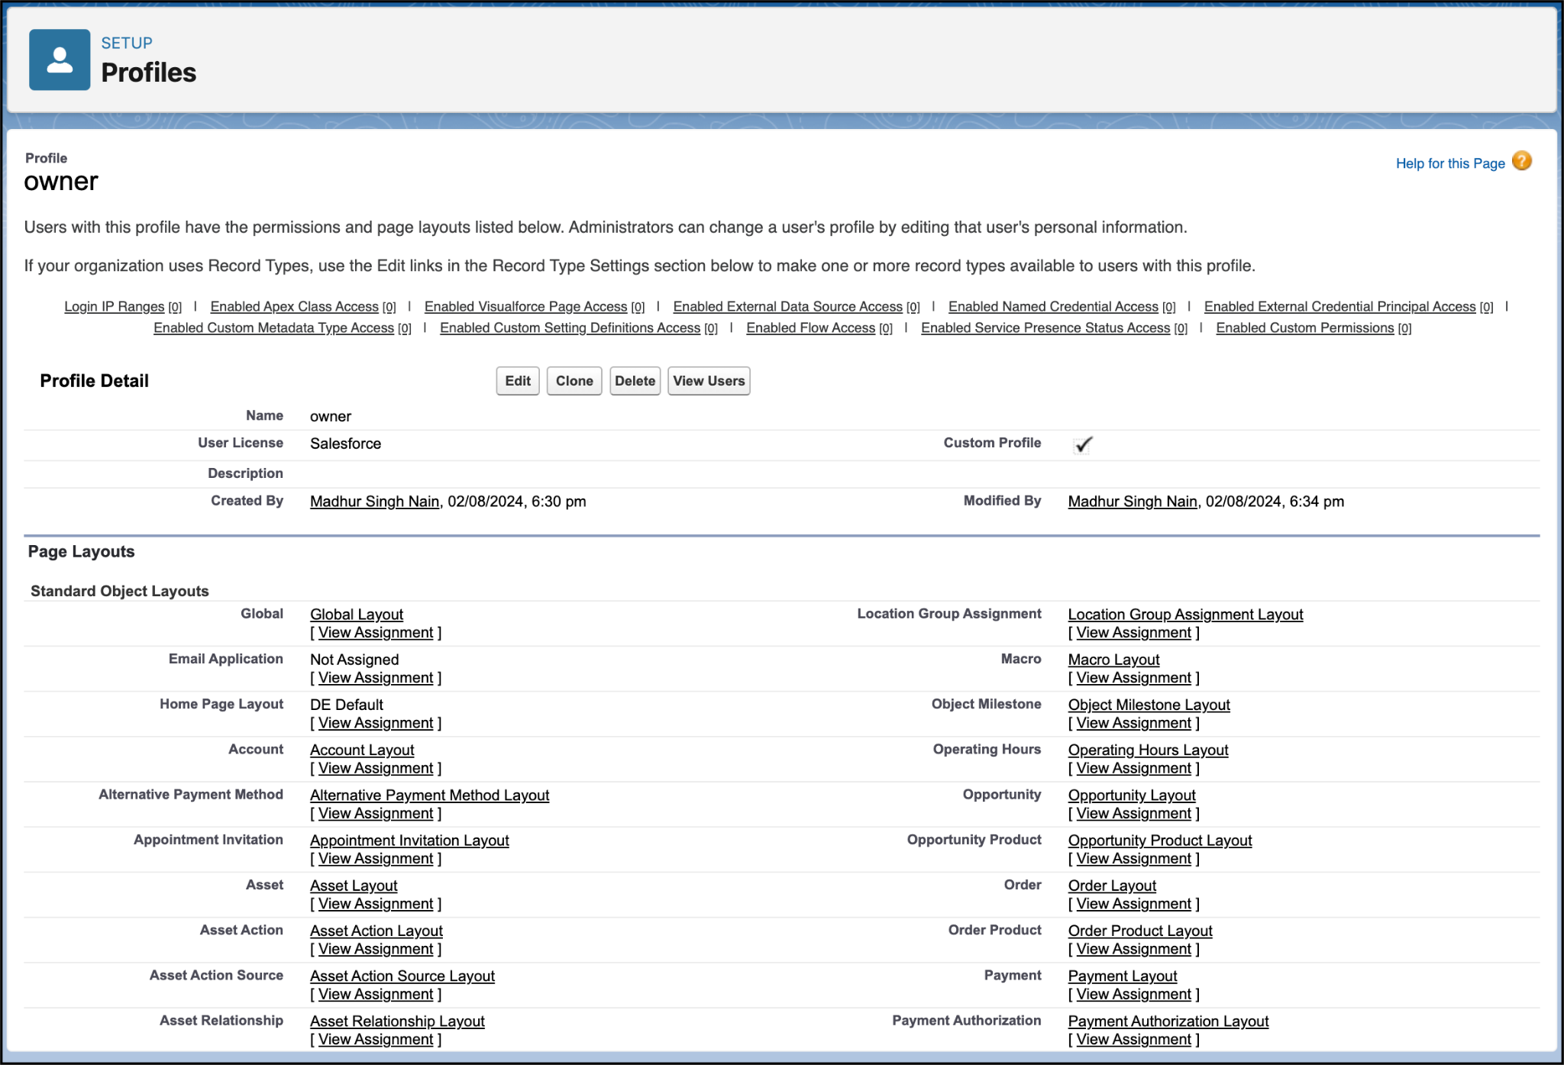

1. Scroll down to Custom Object Permissions and Give access permissions for consumers, rice details , rice mill and suppliers objects as mentioned in the below diagram.

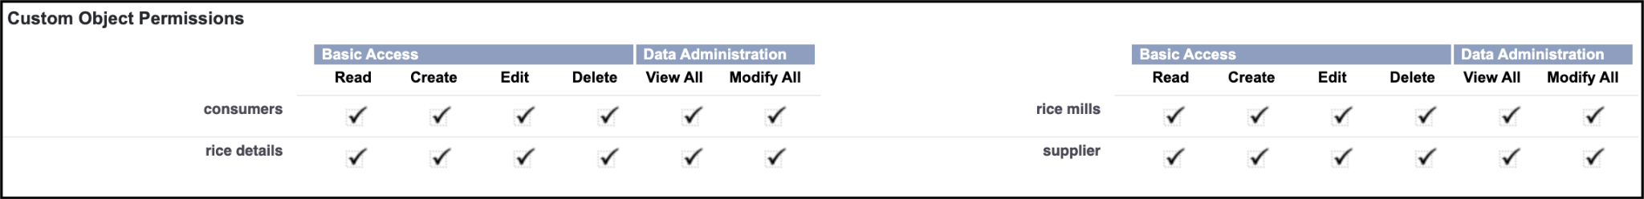

1. Give access and save it.

**Creating Employer Profile**

1. Go to setup >> type profiles in quick find box >>click on profiles >> clone the desired profile (Standard Platform User) >> enter profile name (employer) >> Save.
2. While still on the profile page, then click Edit.
3. Select the Custom App settings as default for the rice mill.

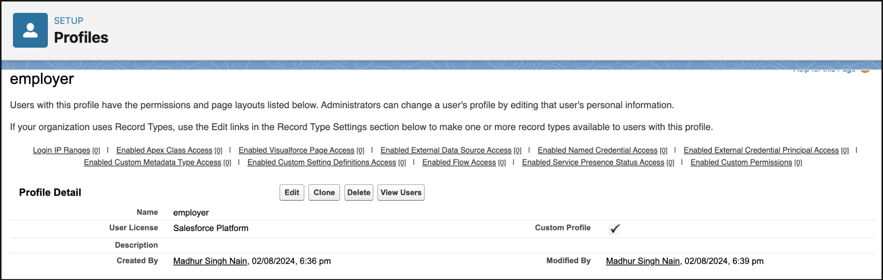

1. Scroll down to Custom Object Permissions and Give access permissions for consumer, rice details , rice mill and suppliers objects as mentioned in the below diagram.

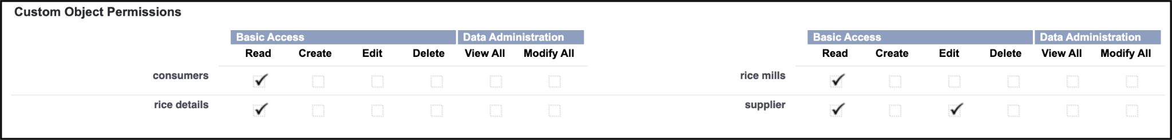

1. And click save.

**Creating Worker Profile**

1. Go to setup >> type profiles in quick find box >> click on profiles >> clone the desired profile (Standard Platform User) >> enter profile name (worker) >> Save.
2. While still on the profile page, then click Edit.
3. Select the Custom App settings as default for the rice mill.
4. Scroll down to Custom Object Permissions and Give access permissions for consumer, rice details , rice mill and suppliers objects as mentioned in the below diagram.

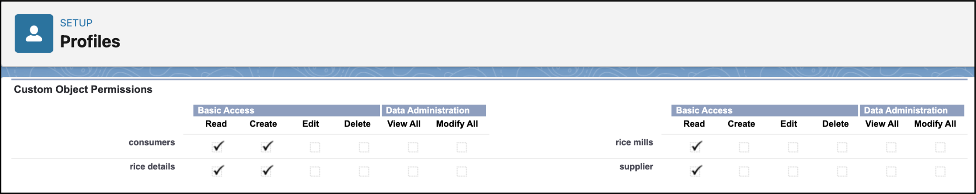

1. And click save.

# **Task 8: Creating Role & Role Hierarchy**

**Creating Owner Role**

1. Go to quick find >> Search for Roles >> click on set up roles.

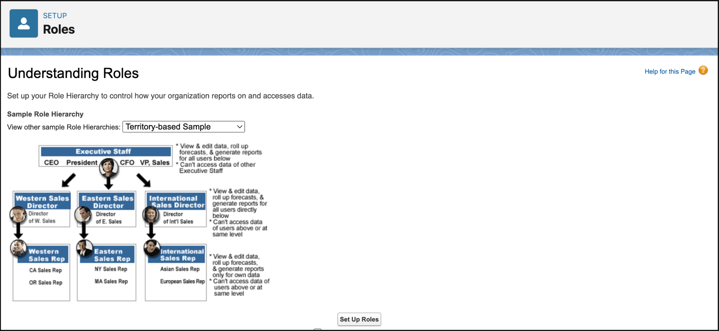

1. Click on Expand All and click on add role under whom this role works.

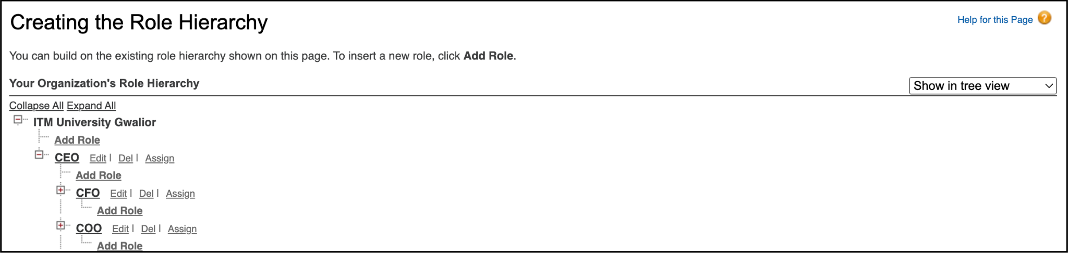

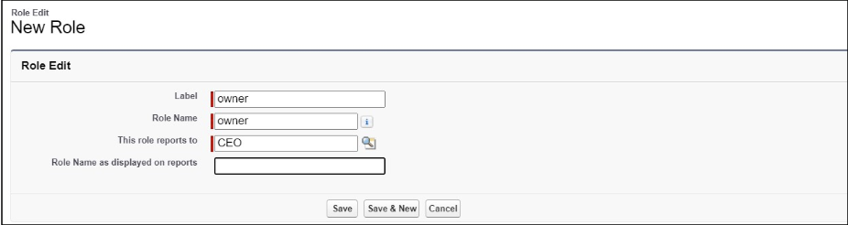

1. Give Label as “owner” and Role name gets auto populated. Then click on Save.
2. Click and save it.

**Creating Employer Roles**

1. Go to quick find >>Search for Roles >>click on set up roles.
2. Click plus on CEO role, and click add role under owner.

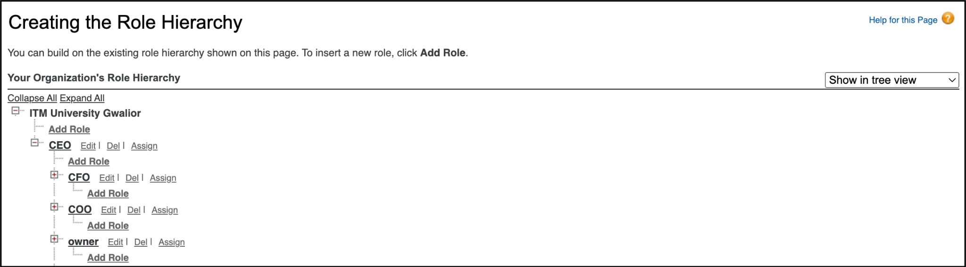

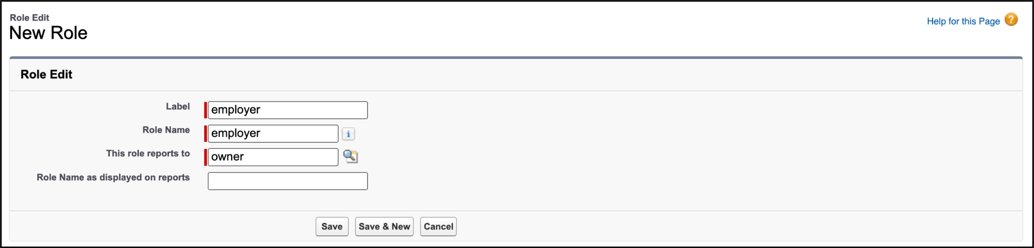

1. Give Label as “employer” and Role name gets auto populated. Then click on Save.
2. Repeat the same steps, for another role.
3. Click plus on CEO role, and click plus on owner, and click add role under employer.

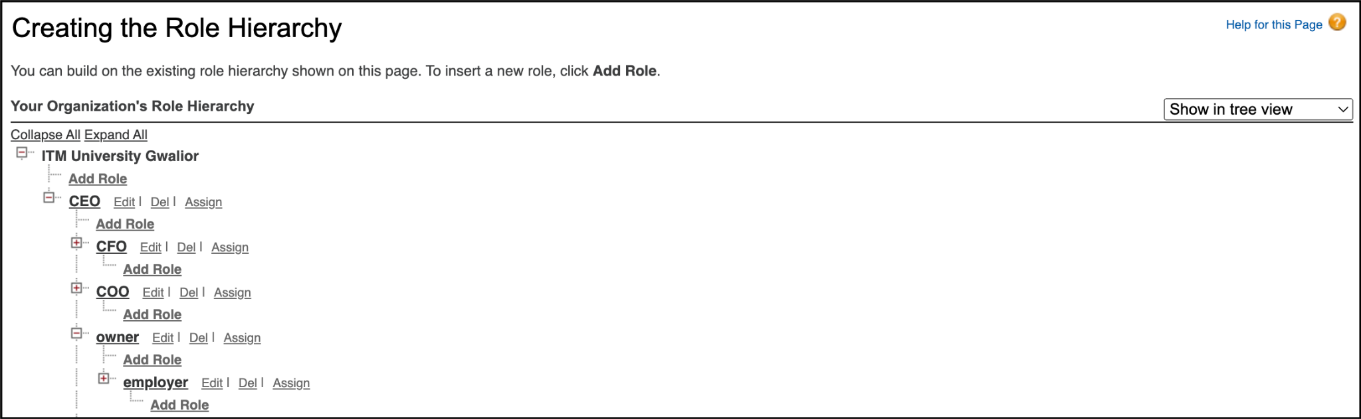

1. Give Label as “worker” and Role name gets auto populated. Then click on Save.

# **Task 9: Creating Users**

**Creating User for role Owner**

1. Go to setup >> type users in quick find box >> select users >> click New user.
2. Fill in the fields :
   * First Name : vicky
   * Last Name : y
   * Alias : Give a Alias Name
   * Email id : Give your Personal Email id
   * Username : Username should be in this form: text@text.text
   * Nick Name : Give a Nickname
   * Role : owner
   * User license : Salesforce
   * Profiles : owner.

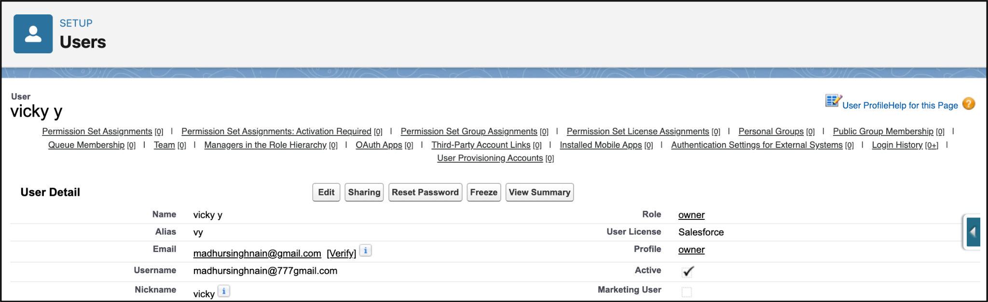

**Creating User for role Employer**

1. Go to setup >> type users in quick find box >> select users >> click New user.
2. Fill in the fields :
   * First Name : ram
   * Last Name : ram
   * Alias : Give a Alias Name
   * Email id : Give your Personal Email id
   * Username : Username should be in this form: text@text.text
   * Nick Name : Give a Nickname
   * Role : employer
   * User license : Salesforce Platform
   * Profiles : Standard Platform User.

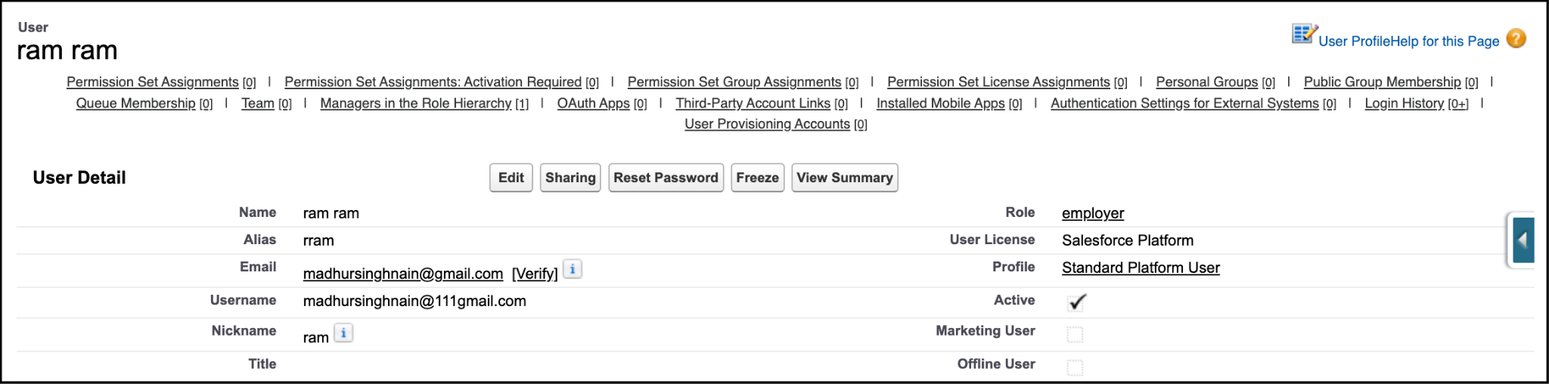

**Creating User for role Worker**

1. Go to setup >> type users in quick find box >> select users >> click New user.
2. Fill in the fields :
   1. First Name : ragu
   2. Last Name : raj
   3. Alias : Give a Alias Name
   4. Email id : Give your Personal Email id
   5. Username : Username should be in this form: text@text.text
   6. Nick Name : Give a Nickname
   7. Role : worker
   8. User license : Salesforce Platform
   9. Profiles : Standard Platform User.

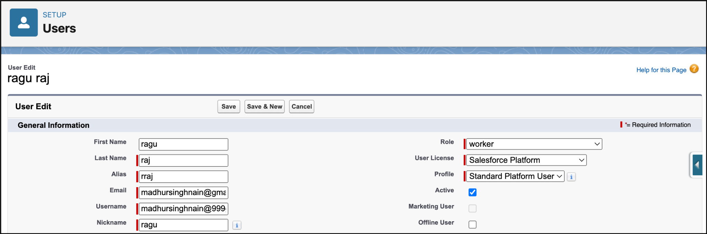

1. Save it.

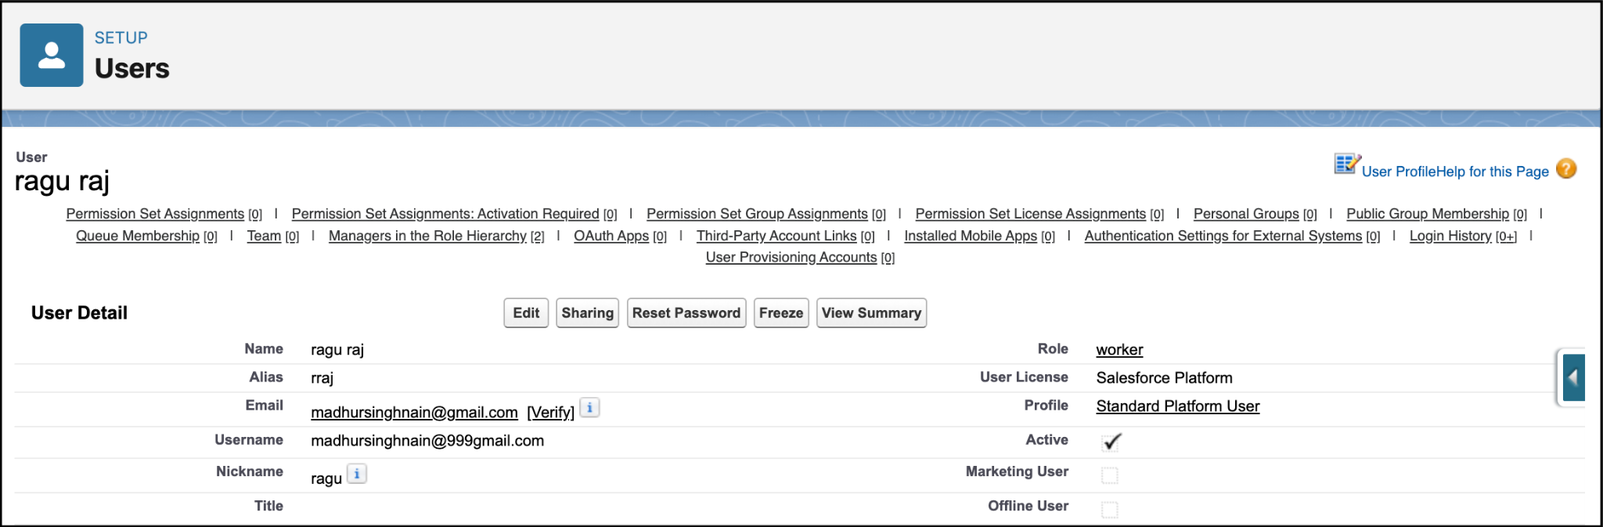

# **Task 10: Creating Permission Sets**

**Creating OWD Setting**

1. Go to setup >> type “sharing settings ” in quick search >> Click edit.
2. Scroll down, change the default internal access to “ public read-only” for rice mill and supplier object.

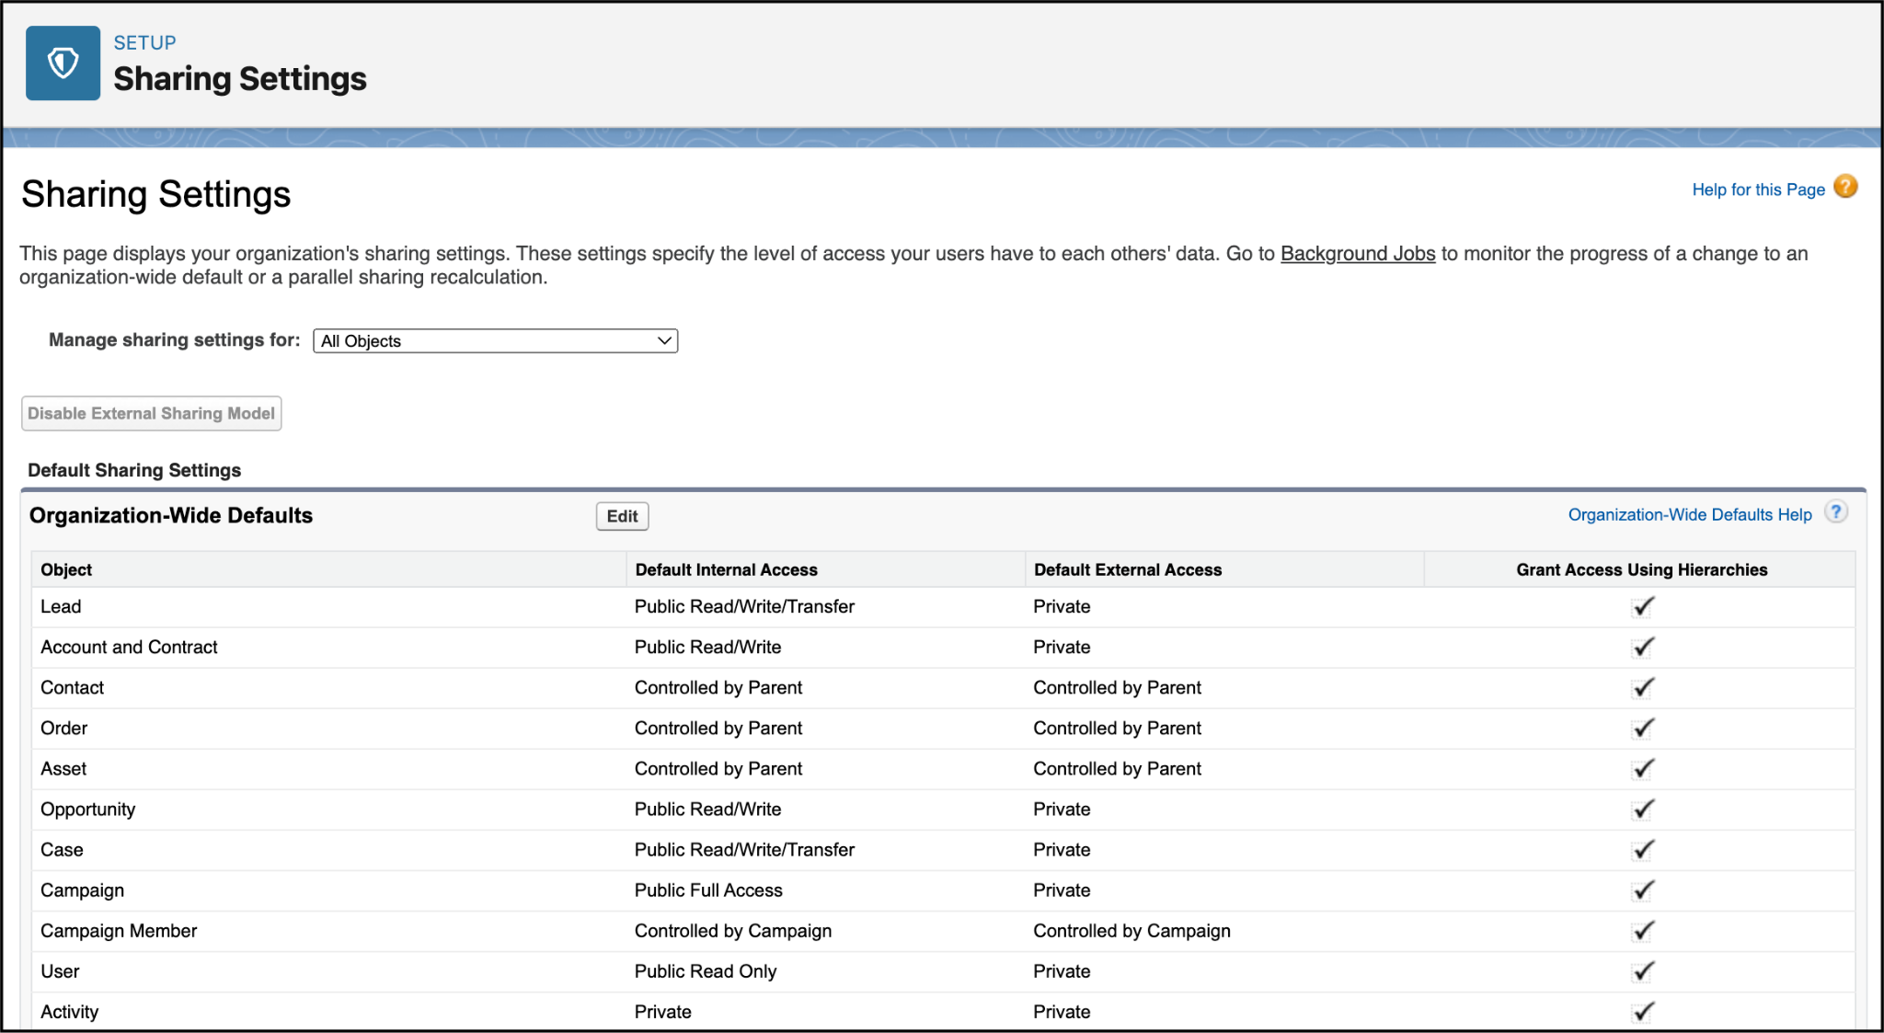



1. Click save.
2. Extra information, By these every profile has their own access, according to their profile.
3. But in our case we created roles and given the roles in such a way that the owner can see employer and worker records , and the employer can see the worker records.

# **Task 11: Creating Reports**

**Creating Report**

1. Go to the app >>click on the reports tab
2. Click New Report.

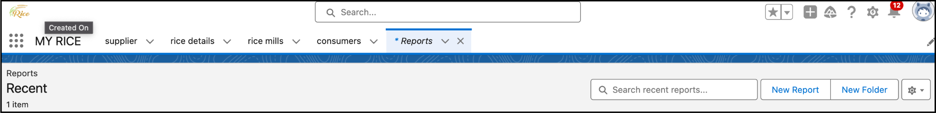

1. Select for report type, search for “rice mill with consumers” click on it. And click on start report.
2. Their outline pane is opened already, select the fields that are mentioned below in the column section.
   1. consumer name
   2. rice type
   3. rice price/kg
   4. mode of payments
   5. amount paid
3. Remove the unnecessary fields.
4. Select the fields that are mentioned below in the GROUP ROWS section.
   1. Rice taken by shops

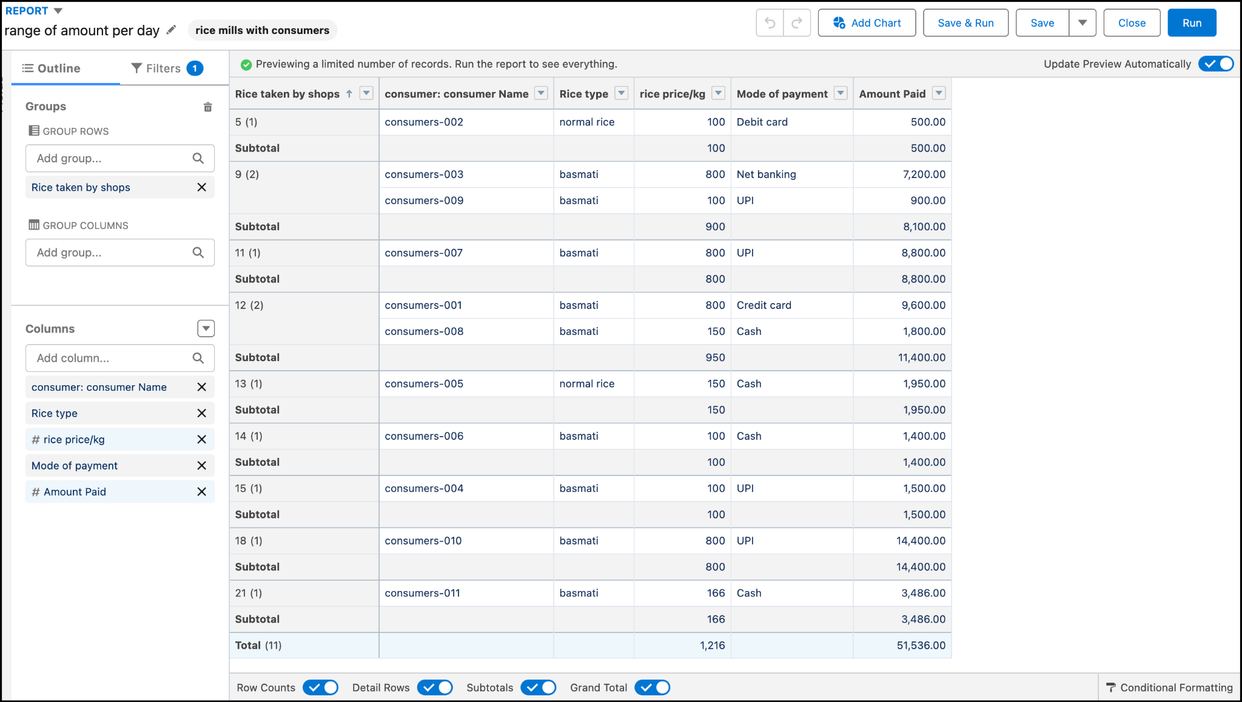

1. Click Save & Run and save the report as “range of amount per day”.and save it.

**Sharing Report To Owner**

1. Click edit drop down and select subscribe option.
2. Follow as per below image.

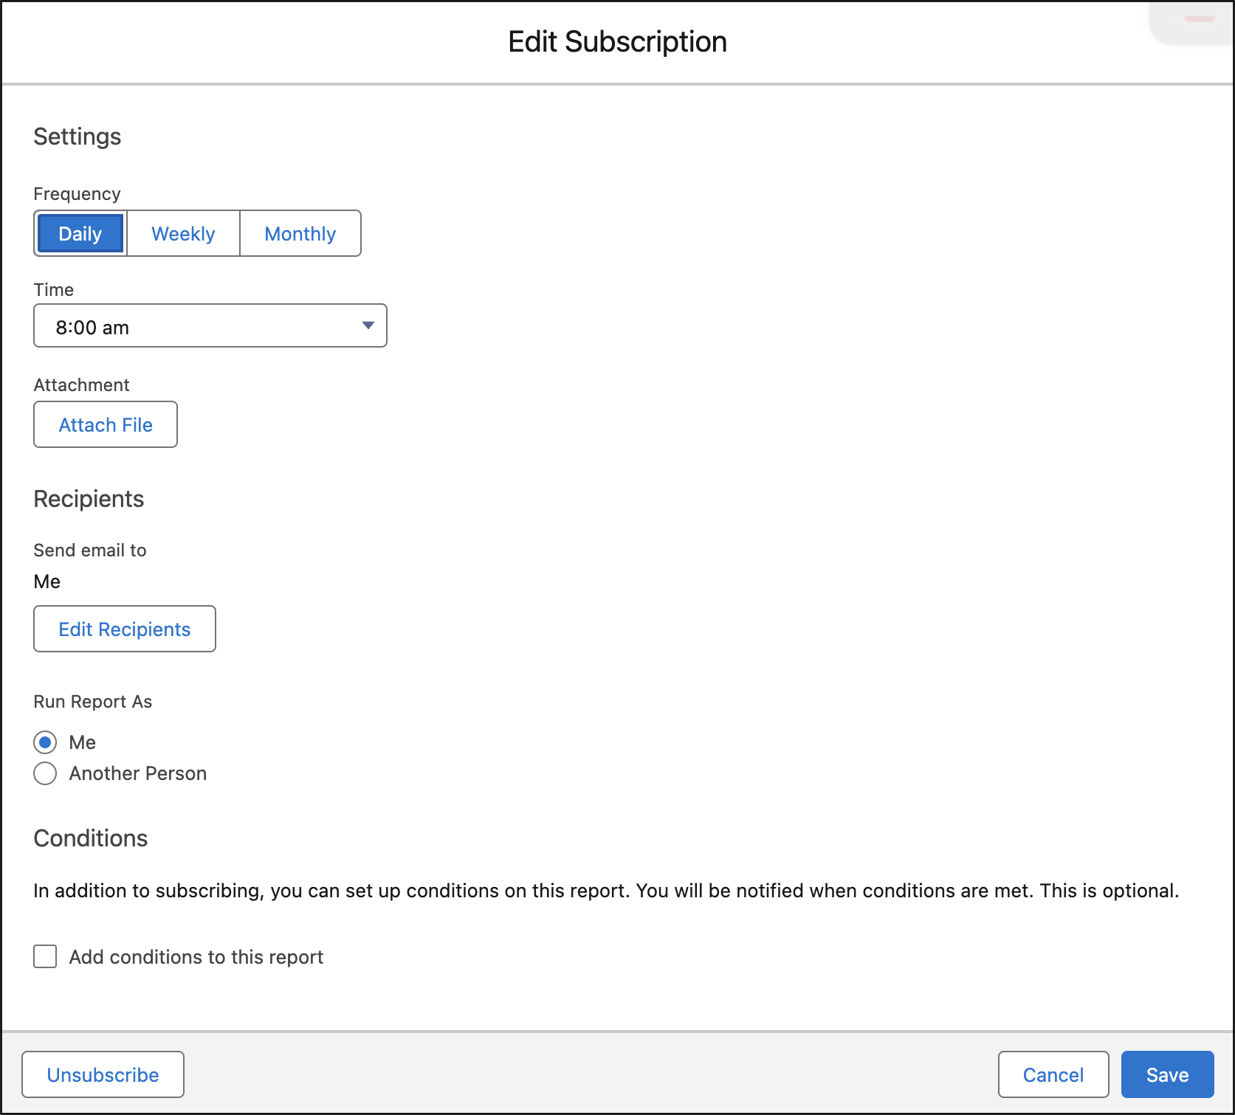

1. After selecting the run report as a “another person” select your personal account or whom you want to send that mail to.
2. Click save.

**Create A Report Folder**

1. Click on the app launcher and search for reports.
2. Double click on the report, “reports tab” will be auto populated in the navigation bar.
3. Click on the report tab, click on the new folder.



1. Give the Folder label as “estimated rice per day ”, Folder unique name will be auto populated.
2. Click save.

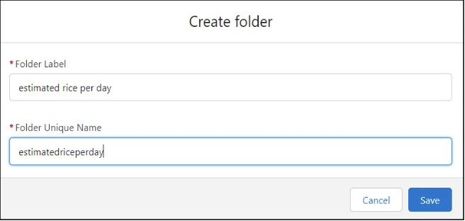

1. Navigate to app launcher and click reports on that.
2. Click all reports.
3. Select the range of amount per day drop down in that click move.
4. Select estimated rice per day folder and select folder.

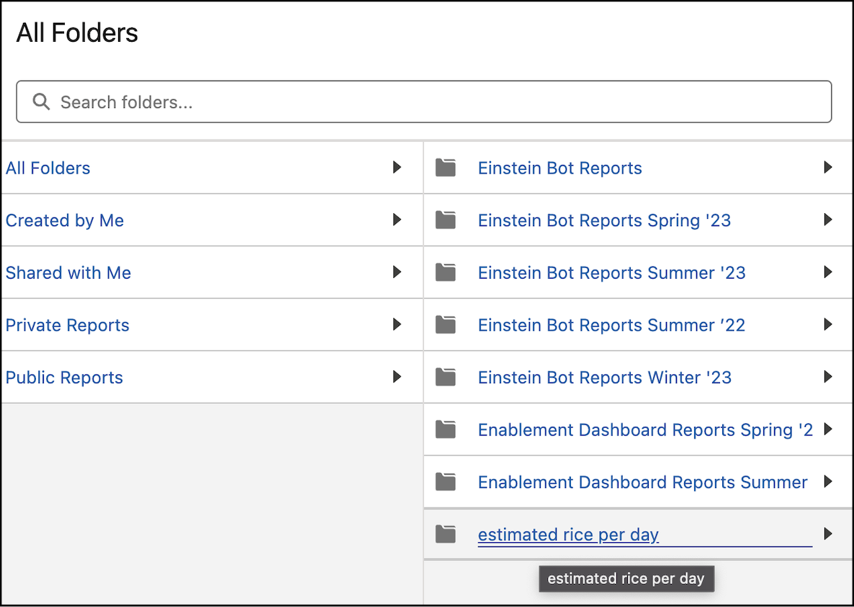

# **Task 12: Creating Dashboard**

**Create Dashboard Folder**

1. Click on the app launcher and search for the dashboard.
2. Click on the dashboard tab.
3. Click the new folder, give the folder label as “ amount data dashboard”.
4. Folder unique names will be auto populated.
5. Click save.

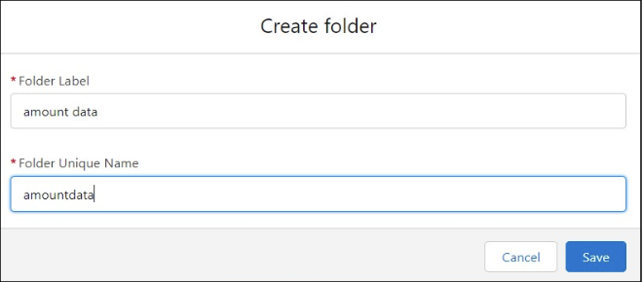

**Create Dashboard**

1. Go to the app >> click on the Dashboards tabs.
2. Give a Name and select the folder that was created, and click on create.
3. Select “+widget” component.



1. Select a Report (range of amount per day) and click on select.
2. Preview is shown below.

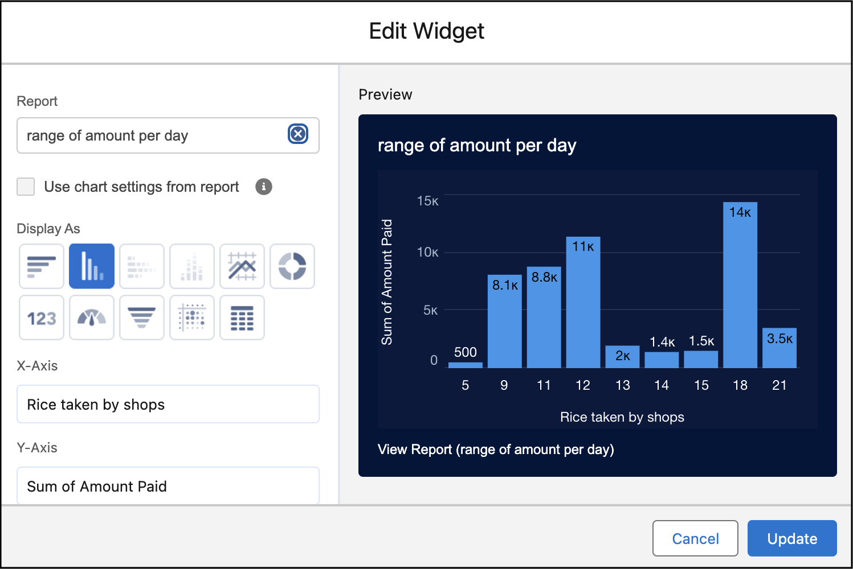

1. Fill in the fields :
   1. Display as>> vertical bar chart
   2. X-axis >> rice taken by shops
   3. Y-axis >> sum of amount
   4. Y-axis range >> automatic
   5. Sort by >> rice taken by shops
   6. Component theme >> dark.
2. Add the component
3. Again select add component with above same steps
   1. display >> donut chart
   2. sort by >> sum of amount
   3. title >> range of amount per day
   4. component theme >> dark

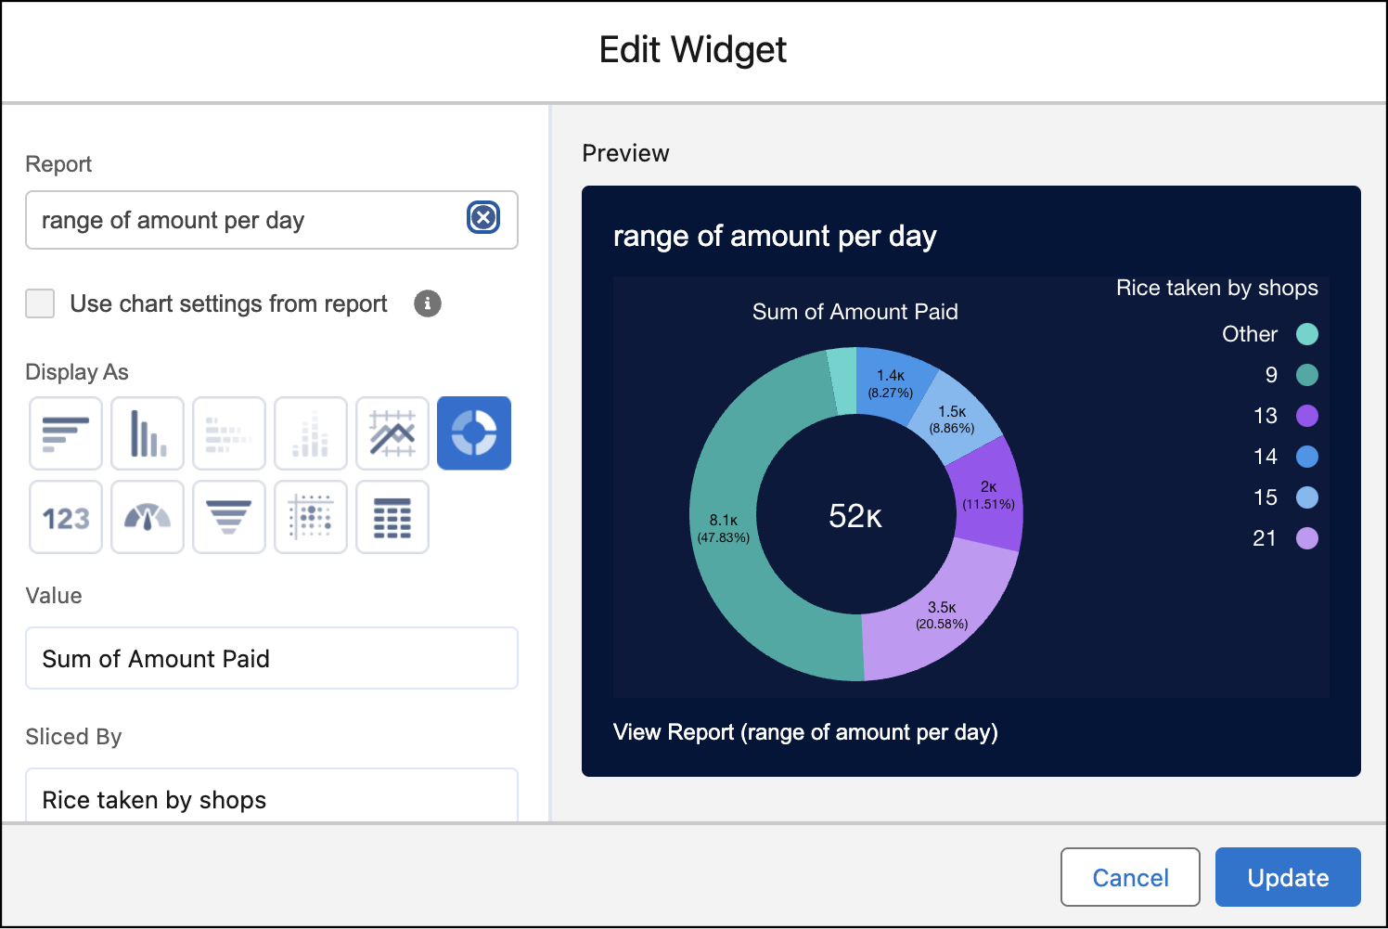

1. Click Add
2. Click Save & Done

# **Task 13: Creating APEX**

**Creating An Apex Class (ConsumerRecord)**

1. Login to the Salesforce account and navigate to the gear account in the top right corner.
2. Then we can see the Developer console. Click on the developer console and you will navigate to a new console window.
3. Then you can see many tools in the Toolbar of the new console window. Click on File, New and Apex Class.
4. Enter the name of the class(ConsumerRecord) to create a new class file.
5. Code snippet :

public class ConsumerRecord {

public static void sendEmailNotification(List<consumer__c> con) {

for (consumer__c c : con) {

if (c.email__c != null) {

Messaging.SingleEmailMessage email = new Messaging.SingleEmailMessage();

email.setToAddresses(new List<String>{c.email__c});

email.setSubject('Welcome to Our Company');

String emailBody = 'Dear ' + c.Name + ',\n\n' +

'Welcome to MY RICE!\n\n' +

'You have been recognized as a valuable customer to us. Please continue your journey with us, while we strive to provide you with the highest quality resources.\n\n' +

'We are proud to associate with customers like you and look forward to collaborating by offering more exciting discounts and product offers.\n\n' +

'So why take a step back? Take a leap of faith and shop with us more, while we continue to provide you with valuable products and offers.\n\n\n' +

'Thank you for your purchase of ' + ' [Product Name] ' + '. Here are some other products purchased by customers who bought similar items:\n\n';

email.setPlainTextBody(emailBody);

Messaging.sendEmail(new List<Messaging.SingleEmailMessage>{email});

}

}

}

}

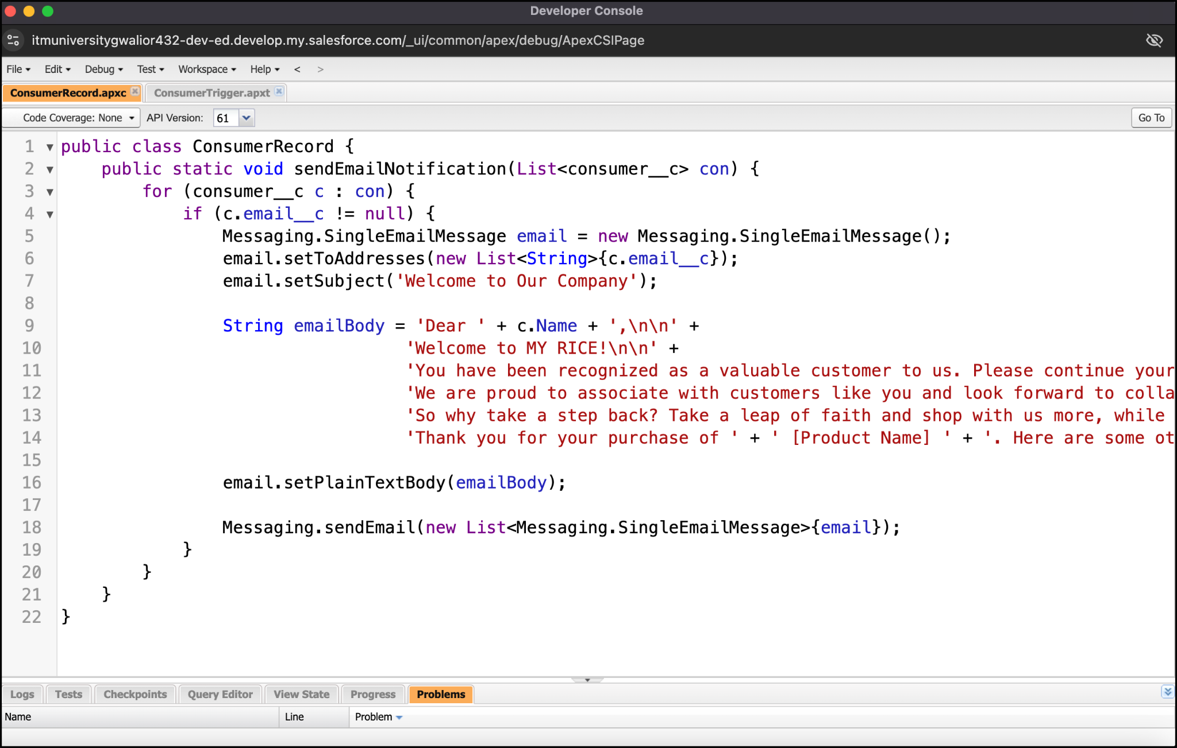

**Creating An Apex Trigger**

1. Login to the Salesforce account and navigate to the gear account in the top right corner.
2. Then we can see the Developer console. Click on the developer console and you will navigate to a new console window.
3. Then you can see many tools in the Toolbar of the new console window. Click on File, New and Apex Trigger.
4. Enter the name (ConsumerTrigger).
5. Enter sObject (consumer__c).
6. Code snippet :

trigger ConsumerTrigger on consumer__c (After insert) {

if(trigger.isAfter && trigger.isInsert) {

ConsumerRecord.sendEmailNotification(trigger.new);

}

}

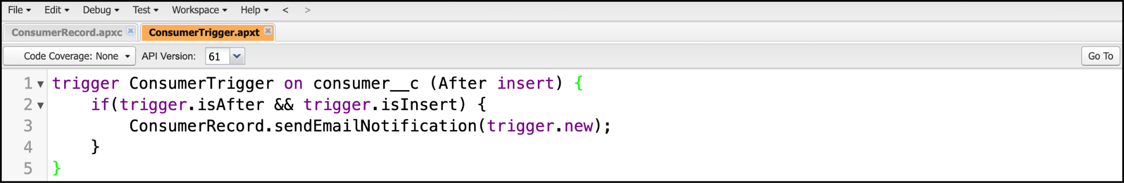

# **THANK YOU**